Generation of Random mazes / Maze like Levels and Creation of a Game Using them

Project Final Submission

De Montfort University

Computer Games Programming

Jake Coffey – P15187559

Contents

Abstract 3

Introduction 5

Analysis of Requirments 6

Level generation 6

Core Game Components 7

Enemies 7

Player Character 7

UI 8

Items 8

GameStates 8

Analysis Conclusion 9

Design Considerations 9

UI Considerations 9

TExture Loader 10

Sound Manager 10

Main Menu, Permadeath, and Upgrades. 10

Save and Load 11

Smart pointers 12

Despawn and SpawnManager 12

Implementation 12

Texture Loader 12

Sound Manager 13

Smart pointers 13

Physics 14

Collision Listener 15

Maze Generator 15

Spawn Manager 16

Despawn Manager 17

LevelManager 17

Menus, UPGRADES, and UI 18

Mini Map 18

PlayerCharacter 19

Torch 19

Camera 19

Animation 20

Enemies 20

Traps 21

Items And Treasure Chests 21

Conclusion 22

Product Evaluation 22

Approach 23

Tools Evaluation 23

Conclusion 24

Bibliography 25

Appendix 26

[1] UI Design original 26

[2] UI DESIGN EDITED 26

[3] Actual UI Design 27

[4] Left texturelaoder being made and extern and sf Texture objects being created. Right, examples of loading textures 27

[5] UML Original Idea Diagram 28

[6] UML Diagram Updated 29

[7] UML Final 30

[8]Class Diagram Showing Functions and Variables – Also Availble To view in Visual Studio and As Image in project Directory 31

[10] Original Menu Design 34

[11] Final Menu Design 34

[12] Shared_ptr example creating a skeleton enemy 35

[13] Shared_ptr iterator issue 35

[14] Spawn Manager function calls 35

[15] Spawn Manager enemy creation example 35

[16] Despawn example 36

[17] Box2d Body and Fixture creation example 36

[18] Collision Listener example 36

[19] Finite State Machine 37

[20] Signal Manager 38

[21] Updating upgrades GUI 38

[22] UI fuel bar updates 39

[23] Item UI update 40

[24] player update 40

[25] Player’s Fixtures 40

[26] Torch 40

[27] Torch Update 41

[28] player animation example 41

[29] Flipped Animation Example 42

[30] player spotted method 42

[31] Spike Trap 43

[32] trap transforming example 44

[33] Draw Culling 44

[34] Item effects Details 45

[35] Treasure Chest Item Creation 45

[36] Items 46

[37] Testing Plan 47

[38] Test Log 47

[39] Gantt Chart and Project management 55

Original Gantt Chart plan: 55

Actual Gantt Chart: 55

BackUps – GitHUb 56

GITHUB Link: 56

BackUp – USB 57

Credits 58

Game Instructions 58

Controls 58

GamePlay 59

Game / Project maintenance 59

Running Game 59

Visual Studio Solution Maintenance 59

# Abstract

Random generation of various content in games has become commonplace in a subset of games that use some level and style of random generation to design the layout of the game level and what content from a pool is used in each level. The level of random generation in each game varies, with some using pseudo random generation that takes pre-built level portions and content spawn points and combines them in a random way, and others using true random generation with some limiters applied to prevent problems such as content being created within each other. Generation of levels can be a complex matter, with various and varied methods exiting that provide a wide range of different outputs and levels of complexity. The majority of these can and are applied in creating maze or maze-like levels, with random generated dungeons in games typically resembling mazes. The purpose of this project is to take a method a random generation and apply it to creating maze like levels to be used in a game. The game style used in combination with the generated levels is a “rogue-like” game, where the level and content (enemies, items, traps) are randomly generated and placed throughout the levels to allow the player to progress. This project shows various generated levels that, while not resembling the typical perfect maze (hedge maze style), resemble a non-typical clear maze-like structure, as well as a rogue like game that utilises these levels appropriately. The process and reasons for the generation and game creation choices will be discussed in this paper.

# Introduction

The program created consists of a fully-fledged game that fully utilises random generation to create maze like levels, not using any pre-set combinations of level designs to achieve “random levels” and instead using an algorithm that randomly iterates through “cells” of the level and chooses which cells should be open walls or open, with some limits set in place, discussed in the generation segment of the report, to ensure a navigable and maze like structure is generated. The algorithm used is similar to a style of generation know as recursive backtracking, that chooses a random direction each iteration and creates a path or wall in that direction if it can, continuing until it can no longer do this and then going back until it reaches a cell where it can continue this process. The differences between this algorithm and the method implemented will be discussed in the generation segment of the report. Creating levels that both resemble a maze-like structure and are suitable for a game level is a challenge that required good programming and debugging skills as well as creativity in the approach used in the implementation. The game implementation also uses random generation to some extent to populate the generated levels with content from the pool of enemies, items and traps created as part of the project in order to give the structure of a “rogue like” game that allows the player to progress and improve in each run through the game.

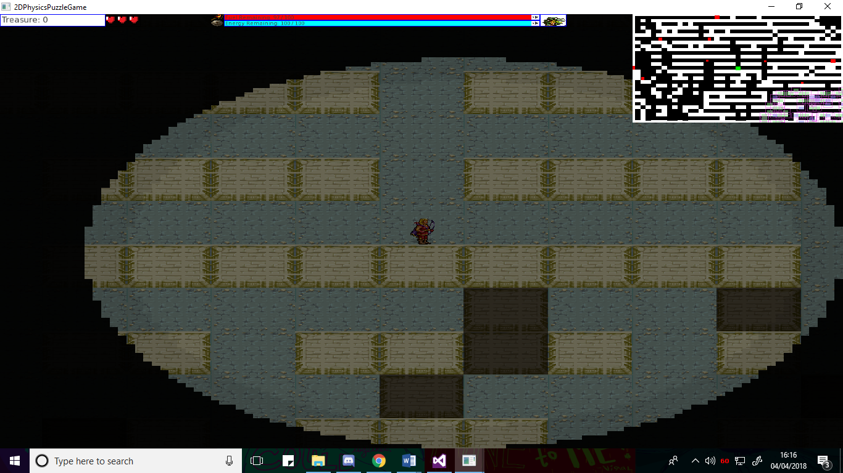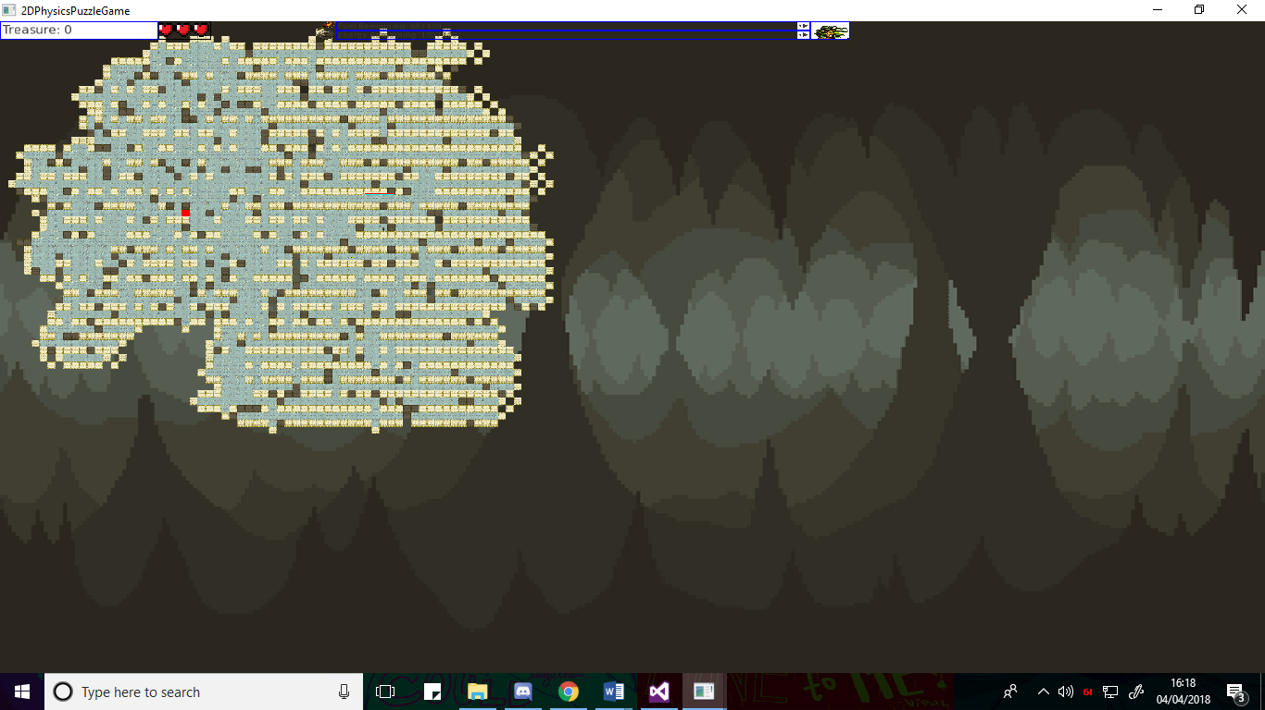

Fig.1 – Left shows the normal view of the game. Right shows a zoomed out shot of a generated level.

While various rogue like games and level generation algorithms and methods exist, the two in combination are typically not done with true randomness, instead using the randomness algorithms to piece together procreated level portions and content in a random manner. As such, a portion of the reasoning behind the project was to see how effective the level generation would be for a rogue-like game when not using pre-set portions of levels and instead generating the level randomly through a set of iterations, limitations and an algorithm, and then attempting to create a fully functioning game.

Portions of the project are similar or utilise functionality that I have experimented with previously, where as other sections of the game created are completely unlike anything I have undertaken before. As such, this, in combination with the previously mentioned need for creativity in the implementation as well as good programming skills, knowledge, debugging skills and research skills, forms further reasoning for undertaking this project, as it expands upon existing knowledge, as well as providing experience in new areas, allowing for a development of further knowledge and experience in programming various parts of games, and algorithms. Likewise, the amount of content need for a good project as well as for a good “rogue-like” game allows for creativity and experimentation with programming that also leads to further expansion of personal experience and knowledge. For example, I have created games before, however I have never developed items in a game that can be acquired and used to change how the game plays, and this project provided the opportunity to experiment and create a variety of these, developing my skills in game creation.

Further reasoning behind the project is the previously mentioned libraries being used. Undertaking this project allows for further development of skills utilising external libraries, something that is typically required when creating ambitious and complex games, as well as developing skills in the specific areas each of the libraries covered, these being, physics and collision form Box2D, game management, sound and sprite creation from SFML, and GUI creation and management form TGUI.

# Analysis of Requirments

The project can be split down into a group of two different major components that themselves can then be split down into smaller, important for them, components. The two major components of the project were the maze / level generation and mechanics related to that, and the core rogue-like game component.

## Level generation

Level generation was one of the key points of the project proposal, the proposal being to create a game in levels that were randomly generated each time and resembled a maze-like structure upon creation. As such, it was obvious that one of the major components that would need to be focused on was the level generation. Due to the required randomness of the levels, this component of the project would require an algorithm of some kind to be implemented to create the levels on the projects being run, rather than the typical pre-set level design coded into either the project source code or loaded from an external file that the majority of games utilise. Fortunately, research into this area had already been undertaken as part of the first hand in literature review, which specifically researched and discussed various algorithms or methods of level generation. The requirement to keep the levels either as mazes or resembling maze like structure ruled out some of the researched generation methods and algorithms, such as cellular automata, due to them producing results that resembled other structures, such as cave systems, more than they did a maze-like structure. This culling of certain algorithms led to the conclusion that the algorithm utilised would need to be an algorithm that has limits placed on how it created the level, for example making sure the cells are connected before creating a piece of the level there and directions limits, to ensure a coherent maze-like structure where each segment was accessible and connected.

The level generation would also require some method of taking the result of the algorithm and actually making the level from it. This was required, since the algorithms typically only created a template to be used such as an output of different numbers for each type of cell there could be, and the algorithm itself didn’t have any way to create a visual representation of the output. The visual and physical representation of the maze would need to be created from the algorithm output by utilising a method to create an object in the project. In the case of this project, the visual would need to be created from SFML and the physical representation from Box2D, as these were the libraries Utilised to create visuals and any physics and collision.

## Core Game Components

To produce the game element of the project, various components were required, with some being general game requirements, and others being requirements needed specifically because of the rogue-like genre aimed for. The majority of the below are also listed as goals in the project proposal and contract, and as such were required to properly fulfil the contract and complete the project.

### Enemies

A key component of the project was enemies. Enemies are an engaging element in a majority of games that allows the player to interact with something other than the environment and any environmental objects such as puzzles. Enemies were viewed as a core component for the game element of the project because the project intended was not an exploration style game and needed to be more engaging and complex than simply finding the exit of the maze and proceeding to the next level. Enemies provided both a hinderance to the player that they would have to overcome, providing an extra element of challenge, as well as another element for the player to engage with, since having a number of different enemies would require the player to consider what they were doing and what they were facing before taking action, rather than blindly exploring. Aside from my reasoning, rogue-like games in general require enemies to properly function, as one of the key elements of a rogue-like game is a dungeon style game and progression, both of which would need enemies, either to populate the dungeon or to provide some method of progressing and something to progress against [7].

The requirements for enemies are shared between the different types of enemies. Each type of enemy would require a visual and physics element, from SFML and Box2D respectively, so that they can be seen and interact/ collide with other elements of the game. All the enemies would require a method of attacking as well, since they need to be able to hinder the player in some way, however this method of attack can vary. Movement would also be required, as the enemy being completely stationary would be both boring and not much of a challenge.

### Player Character

As the game section of the project involved moving around the maze, another requirement was an avatar or character of some kind for the player to control and use to interact with objects and entities in the maze. This was a requirement, since without this, the game would literally be just moving a camera around to look at a maze, with no method, or at least limited methods of interacting with anything else in the game. While there are some types of games that do not require a character for the player to control, these are typically genres such as puzzle games or strategy games, where the player doesn’t require a single character to interact with, something the project didn’t fit into.

A player character, like the enemies, required a visual and physics element to be displayed and interact and collide. Likewise, the player would also need a method of attack to combat the enemies in some way and provide a way to defeat them and thus progress. A method of moving the player would be required to move them around the maze and progress through it. However, unlike the enemies, the player character required other elements to interact with the various items in the game, as well as objects such as a camera, so that the game view would follow the player rather than being stationary, and a torch to fit with one of the mechanics of the game to provide illumination that slowly got darker the longer the player spent in the maze levels.

### UI

Due to the variety of items intended to be included in the game and because the game would have a variety of data that would need to be presented to the player in some manner, a UI element was required to visually represent this information for the player, preferably a graphic interface of some kind for the more professional and eye pleasing look compared to a purely text based interface. The UI was required to display a variety of data important to the player, from their health, to the amount of treasure they had and fuel for the torch mechanic. To properly display this information, a variety of different types of interface were required form the UI. For example, displaying the treasure required the amount of treasure acquired as a number, and so a text box with background was required. Whereas something like the health or the fuel could be displayed purely visually by a bar and image to show what the bar was for or a set of hearts to represent the current amount of health. While all of this could be done with textboxes, it was “required” to have these different UI elements to present a visually pleasing and more professional appearance.

The UI was also required for the “progression” portion of the rouge-like game, as some method, such as buttons, was required to both show and allow the player to choose various upgrades to improve the character and allow them to progress further the next time they played.

### Items

Items are a common feature in rogue-like and rogue-lite games, commonly changing how the game works in some way or providing the player with more methods to interact with their surroundings. These items are sometime bought as parts of upgrades (as mentioned above in the UI), whereas other times they are found during actual gameplay and only last until that bout of gameplay is concluded. Either way, they feature in the vast majority of chosen genre of game, and as such are practically a requirement for the project. They are also required simply because they were listed as goal for the project as part of the contract and the goals set forth in the weekly plan.

The requirements for items are similar to all other physical components of the game, needing a visual and a physics element to be properly displayed and interacted with in the game. Items would also require a way to interact with the player, since they typically manipulate the way the player can act and interact with other elements of the game, as well as typically being activated by the player. Each item would also require a different effect that they create or do so that they have some reason for existing and being used by the player.

### GameStates

Because of the need to have an upgrade menu, as mentioned in the UI analysis above, we would also require some way to control what state the game is currently in, so that it knows when to the Upgrade menu UI code, and when to run the normal gameplay code alongside the in-game UI. Likewise, we would also need to have a method to know what state the game is in to facilitate having multiple levels that the player can progress through, since we would need to know when to delete the level and then create the next one, which while these are being done, the normal in-game code can’t be run and the other state can’t be done. This is because while we are deleting a level, we can’t run the level and load a new one at the same time, since the deleted level can’t be run when pieces of it are being deleted and loading a new level while deleting one would cause a mass of conflicts.

To solve this, we need “Game States” that tell us what state the game is in so that we can do the code and processes in the correct order without them conflicting with each other.

### Analysis Conclusion

The above-mentioned components were required to create the basis for the game, without them, the game wouldn’t have been functional, at least not to a decent and proper capacity. Further elements could be and were included to improve the game, but the above were required.

# Design Considerations

Some elements of the project and game design went through changes and additions to their original design concept or intended method of design. These changes came from a change of direction in the project development due to either additional information, a change of mind, or possible errors and problems that prevented the original design. These Are discussed in this section.

## UI Considerations

The original design of the UI intended to be used [see appendix 1] contained far fewer visual elements than the final design and was mostly designed to display the information as text within a border or shape of some kind. For example, the health bar was originally intended to just be a text box that read out the number of the player’s health. This was redesigned to contain much more of a visual element when compared to the original proposed design, changing the health textbox to be intended as a set of sprites (cartoon hearts) that show how much health is remaining visually, as well as changing the current item to have a sprite of the item behind it for a visual representation [see appendix 2]. This design choice was done mostly because of the introduction of the TGUI GUI library, which allowed for a much more visual UI to be considered and designed through the use of its dedicated GUI methods when compared to the original intention of using SFML text to display the information and sf rectangle shapes for the background and fuel bar. The second intended design also had some other non-visual changes, such as removing the information for the number of ropes and bombs held. This was done because how Items were implemented into the project no longer required a bomb or rope to be held and instead had them be reusable, meaning the number held value was pointless and therefor removed from the design. The mini-map in this design was also moved from the bottom of the screen to the top to fill in the free space that had been created from the changes and make the UI look neater. The final design implemented [see appendix 3] was mostly the same as the intended design with only images next to the fuel bars to represent what each bar was for visually. Other choices considered during the designs included having all of the information on one bar that was then split up into segments to have a solid single GUI that also wrapped around the Minimap. This was considered for the design, since the initial idea seemed like it would be far more professional looking and neater. This design wasn’t used eventually and the above discussed was used, due to the methods believed to allow this from TGUI, proved to not look or function as imagined, spoiling the design, as well as the design obscuring too much of the screen to be of practical use.

## TExture Loader

To construct a game with a professional look and sense of high-quality, a large number of textures and sprite sheets were required to provide all of the game elements with a good looking visual representation that wasn’t just a coloured shape of some kind. Unfortunately, this led to some problems, since the initial two methods of loading textures both had flaws. Initially the textures were loaded all in the main file of the project, and while this worked perfectly fine, it meant passing the textures to any of the created objects that needed them, leading to excessively long and untidy method calls and object creation. This became even more a problem when introducing a level manager, since the textures would first have to be passed to the level manager and then distributed to the objects, leading to passing a significant amount of textures to the level manager and then re-passing them to the correct object methods. To fix this, loading the relevant textures in each object was considered so that passing them would not be required, however this would have led to loading the texture multiple times when creating multiple instances of the objects, with the enemies for example, leading to a waste of memory and decrease in performance.

To solve the above, the decision to create a texture loader was made instead. This texture loader would load all of the textures in one file, much like with creating them in the main, but instead of having to pass them to objects, the texture loader was designed in a manner that allowed any object to access it so long as they were part of the same projects. This allowed for both neater and more efficient texture loading, since all of the textures could be loaded once upon the game starting and then provided to each class without the long untidy method calls. The textures could be neatly loaded in the texturelaoder, and so long as the textureloader.h file was included, any other file could access and utilise the loaded textures as if they had been loaded in their own file. The design of the texture loader was fairly simple, providing all classes with the textures by simply declaring the texture loader as an extern class, allowing it to be accessed from anywhere in the project.

## Sound Manager

The sound manager was created with the same intentions as the above discussed texture manager, providing an easier way to load in all of the sounds and sound buffers as well as managing volume without having to pass the sounds through object creation and method calls. As such, the design decisions behind it were practically the same as the texture loader, with the only difference being the addition of functions to update the loaded sounds so that the volume could be changed through an in-game menu if required. This was added since the sounds, even when given initial volumes to try and balance them out, could be quite loud and so it seemed logical to allow them to be turned down.

## Main Menu, Permadeath, and Upgrades.

Multiple core elements of the game required either a method of continuing the game when not actually in gameplay, or a method of continuing gameplay after a level has completed. For example, to implement upgrades, some method of stopping the gameplay and showing some way of upgrading the player character was required. Likewise, to implement one of the key staples of rogue-like games, permadeath that completely stops the player’s playthrough but provides some method of improving the player, a method of leaving gameplay when the player died, but not ending the game so that the player could carry on playing and improve their character was required. The introduction of menu’s using TGUI addressed both of these issues, as well as improved the professional look of the game, as it allowed for death to take the player back to the menu where they could start again and allowed a method to upgrade the player’s character.

Originally, the design for the game didn’t include a main menu what so ever, going straight into the game when starting it. However, this didn’t allow for the permadeath component of the game to work particularly well, since the game either had to close or restart straight away on death, as well as seeming unprofessional. The Decision to use a menu for player upgrades was an alternative to the original idea to have the upgrades happen in some kind of shop during the gameplay, an idea that wasn’t used because it would have required speech functions and a game freeze function that wouldn’t be sued for anything else and would interrupt the game flow, with the menu with buttons for upgrades seeming like a better choice. The main menu design can be seen in appendix 10 and 11.

The permadeath feature design originally intended for the player to be returned to the start of the game and they would play again straight away, restarting with absolutely nothing. However, as mentioned above, this seemed unprofessional and could be jarring, and so with the inclusion of the menus, the design decision was made to change the permadeath to taking the player back to the main menu, where they could start again if they wanted. Permadeath features typically remove something form the player that they gain during gameplay, to “reset” the character, as such it was originally designed to remove all items, treasure and upgrades from the player so that they started completely fresh. However, this made the game quite hard to progress in and seemed too punishing once content in the game started getting filled out. As such it went through a number of iterations, until it was settled on removing all the items from the player and some of their treasure, but not upgrades, so that there was a form of lasting progression.

## Save and Load

While the permadeath feature mentioned above is intended to punish the player for dying and in a sense add replay ability, since each run should allow the player to progress slightly more, progression only lasted until the player closed the game, at which point the player would be completely reset since the next load would be the default game project settings. This removed the sense of constant progression and reduced the appeal of the game, since everything would be lost once it was closed anyway. As such, the decision was made to include a save and load system to allow the player to carry on progressing if they ever played again and preventing some of reduced appeal of losing everything.

However, the game still required death to be punishing, and so couldn’t allow saving during the gameplay, since the player would be able to just save and reload if they were doing well and somehow died, cheapening the experience somewhat. As such, the save and load functions were designed to only be available from the main menu. This required the main menu design to be tweaked slightly to include to new options, which can be seen in the final main menu design in appendix 11 when comparing it to the original design idea in appendix 10.

Other methods of saving could have been to only allow saving once the player reached certain checkpoints, since this would reduce the player’s options to cheat the game by saving whenever they wanted, instead allowing to save their progress but only infrequently. However, this would still allow for the above-mentioned problem to some extent and seemed like a poor choice, since the player wouldn’t be able to save at all if they didn’t reach a checkpoint.

## Smart pointers

During the creation of the various enemies and items, the conclusion was drawn that using standard raw pointers for creating the objects and pushing them into the back of vectors was a poor method of creating the objects, since it would require a large amount of memory management to properly clean up the pointers both at the end of a level and during gameplay itself, since memory management would have to be performed whenever an enemy was killed to prevent a memory leak and free up the memory properly.

Instead, the design decision was made use smart pointers instead, as smart pointers are designed in a way that allows them to manage their own memory and safely dereference themselves and free up their memory when they are no longer needed. This would stop the need for extra classes and functions to manage the memory for destroyed objects during gameplay as would have been required if the raw pointers were still used.

## Despawn and SpawnManager

The design of the project was changed during the project to include both a despawn manager and a spawn manager, as can be seen in the UML diagrams in appendices 5 to 7, to handle the creation and destruction of the enemies, items and treasure. These functions were originally just handled in the update function that updated the rest of the level for destruction and in the level load function for the spawn manager. However, both the spawn and despawn functions were quite long, requiring a moderate amount of code for each type of object and there being numerous types of objects. As such the update and level load functions became very crowded with code and were quite hard to read, so instead, to make the project and code look more organised and managed, the object destruction code was moved to the despawn manager and the creation code was moved to the spawn manager, so that the functions could be done with single line calls rather than blocks of code.

# Implementation

This section will discuss how various sections of the project were implemented in regard to how they were coded and how the desired effects were achieved.

## Texture Loader

The intent and design decisions behind the texture loader have been explained in the design considerations segment above. Much as discussed above, the texture loader simply created and loaded all of the various textures for the game in one file upon starting the game so that they could be accessed from this file. This was done using the in-built SFML texture objects and their load from file method to take a file path to the relevant image wanted as a texture and then load it and apply it to the texture object. These texture objects could then be used to apply the texture to a SFML rectangle to draw the texture instead of the rectangle shape or used as a sprite by creating a SFML sprite object from them. The loading method can be seen in appendix 4.

However, this wouldn’t allow other files to access the objects. To achieve this, we had to declare the textureloader.h as an external object, [see appendix 4], and create a single instance of it within the main.cpp file of the project. Doing this made it so that the methods and variables, i.e. the texture objects, could be accessed by any file in the project so long as the textureloader.h file was included and used to set the texture over the top of the objects rectangle to use the texture instead. The reasoning behind doing this was discussed above in the design choices segment. The reason that declaring the texturelaoder as an extern allowed for this is because doing this sets the project to refer to the same instance of the object throughout the entire project, and so once the single instance was created in main.cpp, all references to the texture loader in the project were set to check that instance, allowing for any file to access the loaded textures.

## Sound Manager

The implementation of the sound manager was much the same as the texture loader, using the same method of making it an extern object and creating one instance of it in the main to make it available to any class that included the soundmanager.h file. As mentioned above in design considerations, the main difference was that the sound manager implemented an update function to change the volume of the sounds if needed. This update function, [see Appendix 9], worked by checking two variables and modifying the volume based on them. Firstly, it checked the muted bool to see whether it needed to set all of the volumes to zero, and if it didn’t need to that, it would take the sound volume set by the user and use it as a percentage to multiply the original volume by to decrease the volume. This was implemented like this to allow for a traditional volume slider bar to modify the volume and to address the issue of the sounds being quite loud for some people even after being balanced. This update function is called constantly while the player is in the options menu, to allow the sound volume to update continuously while the player changes the volume slider or presses the mute button.

## Smart pointers

As mentioned in the design considerations, smart pointers were implemented to replace the normal raw pointers used during the creation of the enemies and objects in the game levels and prevented the need for extra memory management functions constantly running in the background for when enemies and objects were destroyed. The function used from namespace std was known as std::shared_ptr, and an example of creating the objects using it can be seen in appendix 12. The shared_ptr works by keeping ownership and knowledge of the object and memory that it is pointing to, unlike raw pointers, so that when the last shared_ptr pointing to the object and section of memory is destroyed, it can automatically deallocate the memory to prevent any memory leaks and do the memory management itself.

Despite how useful and time saving smart pointers sound, they did cause some issues within the project when implemented. For example, some of the enemies and the vectors that held them had already been created before the implementation of the smart pointers, and as such they had to be transitioned to using the new type of pointers instead of raw pointers. This required me completely recreating the vectors and experimenting with how to create smart pointers, since changing the pointer type both broke the vectors, as well as didn’t work with the with the same enemy creation method as raw pointers. This also happened with the cells in the maze generator, since they were also created using pointers and vectors, and required me to spend a period of time modifying the creation of the objects and cells.

They also created problems with despawning the enemies, despite being intended to make this easier, since iterators where used for the destroying the enemies to prevent errors, however, when combined with smart pointers, the normal method of using an iterator would not work. Usually iterators are used like a pointer, using the arrow, to get information from the object they’re being an iterator for, but when used with shared_ptrs, this didn’t work. Instead the iterator had to be dereferenced by making it a pointer to a pointer before it could be used to get whether the object and been destroyed. This can be seen in Appendix 13.

## Physics

All of the objects in the game, (items, player, enemies, maze walls, treasure chest, treasure, traps, etc) have a physics element in the game so that they can collide with each other and react to forces and the aforementioned collisions. To implement this, the Box2D library was used and a box2d world was created to manage the physics of all the objects. Each object in the game, if it requires collision of some kind, is either created with a box2d body or has a body created at some point, since the body is the physics representation of the object and holds information such as the position and size so that this can be added to the world and then used to check for when they collide with each other. An example of body creation can be seen in appendix 17.

Each body and object is also given and created with what is known as a fixture. The fixture holds the information such as the mass, level of friction, gravity scale, etc, and essentially details the information that effects the bodies reaction to a collision or force acting on it. This can also be seen in appendix 17. The fixture is also used to manage which objects collide with each other, using the filter category and filter mask options. The category option details what the current object / body is and the mask details what it will attempt to collide with. If objects about to collide have each other’s category in their mask bits then they collide, otherwise they won’t. The category and mask bits are set using an enum shared between all the classes where each choice is a series of digits. The collision filtering is used for some of the objects to prevent objects that shouldn’t be touching each other for various reasons from colliding, for example, the walls are set to not collide with each other to prevent millions of collision calls lagging the game, and the enemies are set to not collide with treasure and treasure chests so that they don’t get stuck on them.

The bodies originally had an issue where two objects sliding along each other would get stuck at the edges of each shape. This was because of a problem in box2d itself where when the two objects come to the end of each other, it registers the collision between them briefly as colliding on the side and bottom, and so pushes them back and prevents them from moving forward anymore. This was prevented somewhat by changing from using box shapes to creating manual vertices for the body shape where the edges are cut off, which can be seen in appendix 17. This reduced the issue, since it resulted in the side and bottom collision error happening on the slopes of each body, and so the bodies can slide up each other, rather than it reacting like it had hit a sheer wall and being repelled. However, this didn’t completely fix the issue, instead reducing the problem to an infrequent occurrence for enemies, something that doesn’t last too long as they will eventually change direction and get unstuck.

## Collision Listener

The collision listener decides what happens to colliding objects and is typically auto managed by box2d. however, a custom one can also be made for custom collisions to be used alongside the default collisions. This is used in the project to provide a method to react to collisions between specific objects, for example it allows for the player to lose health when being hit by a trap or enemy, and also lets enemies to take damage when hit by the player’s attacks and items. This was done because the game required a lot of reactions to objects colliding, and it made no sense to do bounding box calculations when the collisions being handled already by box2d could be used for custom reactions alongside the normal ones.

Each function in the collision listener is for collision between different pairs of objects, with each one acting slightly differently because of the different interacting objects, for example the arrow and enemy collision check removes health from enemies, whereas the treasure and player collision removes the treasure and gives the player the value of the treasure.

However, all the functions use the same method to check if the correct objects are colliding. This method is to use fixtures that the collision listener gets as default and check the filter categories of the bodies and the fixtures colliding against an if check, and if they match, it’s those two objects colliding, so it runs that reaction. However, it must check twice for each pair of objects, since it doesn’t say which of the fixtures colliding is which, so we have to check both ways round it can be. This can be seen in appendix 18.

## Maze Generator

The Maze generator runs the random generations algorithm and creates the random level from the output of the algorithm. The algorithm used is similar to a backtrack method of generation, but also differs from it in some key points. Like the backtrack method, the algorithm used loops through, choosing a random direction each time which is the direction from the current cell that the algorithm would “dig” to turn into a floor cell rather than a wall cell, and then moves into the dug cell, only going back to a previously visited cell to try again in a different place if it can’t dig in the direction chosen. However, unlike a normal backtracking algorithm, the algorithm used doesn’t check all of the available directions before backtracking, and instead instantly backtracks as soon as a direction is chosen that can’t be dug through. As well as this, it also has a limited number of iterations of the loop it can do before it stops, where as a traditional backtracking algorithm would carry on until all of the cells and directions had been dug. A third difference is that the backtrack isn’t to the closest cell, and instead any previously visited cell. All of these changes where implemented because they added more randomness to the level and produced more of a “maze-like” level structure I was looking for, whereas the traditional method will always produce a perfect maze, where all the cells are dug through and there is exactly one way to complete the maze, something that didn’t seem like it would be particularly fun in a game.

All of this digging is done to a double array called maze that stores the current state of the cell as an int, with all of the cells in the array being initialised as walls to begin with and changing to floor cells as they are dug through.

While the algorithm produced a nice level that was fairly random, the maze also required more passages and needed fake walls, something that the algorithm above wasn’t programmed to do. So to achieve this, the function iterates through the array again three more times and has a random chance to change the cell to a different type (floor, wall, fake wall) if the conditions were met, namely if it was close to a floor cell to make sure it didn’t just change random cells. This could have been done via a change to the algorithm and adding another rand that chose which type of cell was going to be dug, however that produced less random and dynamic levels when tried.

An iteration through the array that checks if each cell is completely surrounded by walls is also done, but this was for performance reasons, since all the walls had bodies, resulting in thousands of bodies causing lag, so to fix this any wall that was completely surrounded by other walls wasn’t going to accessed and so didn’t need a collision body, so this iteration changed that cell to a different number int so it didn’t get made into a wall with a body.

Once all of this is done, the actual maze is created from the results by checking through the double array and creating a fakewall cell, floor cell, maze cell, exit cell, or no cell based on what the int for that position was. This is then pushed to the back of the vector, so it can be drawn and used.

The output is also saved to an external text file, so that when the player does their retreat run back through the levels, the text file can be read instead so that we can recreate the levels that were generated before to make it seem like they were retreating back through the labyrinth.

## Spawn Manager

The spawn manager handles creating all of the enemies, treasure chests, traps and loose treasure in the level and its functions are called every time a new level is loaded [see appendix 14]. The spawn manager takes the various vectors for the different types of objects and then for each type of object (treasure chest, enemy, trap, treasure), the respective function creates a random number of said object to make within a range using rand(), then uses that number for the amount of that object that need to be created before it can finish looping. While it is looping, it creates a random position for the object, again using rand (), and compares this to the result of the maze generation algorithm to see if that space is being taken up. If it’s not being taken up (i.e. it’s a floor cell), it creates an instance of the object using the smart pointers discussed above and pushing the object to the back of its respective vector, repeating this process until the vector contains the random number of the object generated at the start.

The enemy spawn method specifically is a bit more detailed, containing an extra step and check before it creates an object. The enemy creation function creates all of the enemy types, aside from minotaur, and the number generated for the amount is spread between the types of enemies. To decide which one is created rand is used again each loop for between 1 and 4, with each number corresponding with an enemy type. This is also done with the trap creation method. These spawn methods were used using a lot of randomness to add to the random nature of the levels and make every level feel different even more by randomising both what is in the level and the amount of each thing in the level. See appendix 15 for a visual example of the described.

## Despawn Manager

Similar to the above spawn manager, the despawn manager gets the vectors for the various objects so that it can iterate through them and manage the objects contained within the vectors. Unlike the spawn manager, the despawn manager is in charge of destroying any objects that have been destroyed, killed or collected while the player is going through each level, and as such, its functions are called each update loop to manage the objects and check if anything has entered one of those states.

The despawn manager has an iterator for each of the vectors so that we can safely go through the vector and remove elements using the iterator instead of directly editing the vector while it is also being used in other places in the update for drawing and updating all the game objects. The despawn manager works by first setting the iterators loop to equal from the start to the end of the respective vector. Then for each element in the vector, the iterator basically points to the current element and is used to check whether that object is dead, destroyed or collected respectively. If it is, the objects body is destroyed, and the iterator is set to equal itself minus the current element. Otherwise the iterator moves to the next element. See appendix 16 for an example.

This iterator method of removing the dead elements is used instead of removing the element straight from the vector because of the vectors being used constantly in the update to update every single object. As such, if an element is removed from the vector while it is being looped through for any part of the update, the size of the vector will change, resulting in the update checking for too many objects and creating an error. The iterator method solves this by setting the iterator to equal itself minus the removed element so that it knows it’s size has changed and prevents the error.

## LevelManager

The level manager is used to organise the game, using gamestates and a finite state machine to choose which functions from the level manager should be run at the current situation, for example, when current state is InGameState, the finite state machine will run the update function which draws and updates all the objects in the game. The finite state machine can be seen in appendix 19. The current state is changed when a state finishes and chooses the next one.

Levels are created using the load next level function. If it’s changing level, it’ll first destroy the current level and everything in it using the destroy level function, then would add one to the current level counter and run the spawn manager functions, the maze generation and the ui creation code.

The levels are transitioned between when the player reaches the exit, where the state will be delete level, then will go to create level. Every third level, counted with a counter that is updated each level create, instead went to the upgrade menu state.

Dying uses the same delete level state as the normal level transition, but sets a bool to tell it to go to load menu state instead of load level state

## Menus, UPGRADES, and UI

The menus were created using the TGUI functions to create a TGUI button, textbox,etc that is then added to a base TGUI gui object that will continue to manage them until they are removed. For buttons, they were connected to another function, SignalManager, see appendix 20, that is called when they are clicked and passes a message that is used in the function to check what onclick code should be run for that button. The message was the text on the button.

When the menu’s needed to be destroyed, the gui object was told to clear itself, resulting in all the widgets being removed and destroyed so that they’re not displayed anymore.

The main menu was created with six buttons that each linked to the signal manager, and all except the load and save changed to a different state so that the menu was destroyed, and the FSM moved to the next function.

The Upgrades menu, again consisted of mostly buttons that simply passed a message to signal manager that would then increase the stat being upgraded if the player had enough treasure and increase the total cost based on the message passed. The upgrades all worked like this, literally just being numbers that were increased by a multiplier each time the button was pressed, and the treasure removed. However, the upgrade menu also had text boxes to show the costs, that were updated constantly by going to another state when the menu was finished creating that would keep checking the values and setting the text to be the result of the cost * the cost multiplier. See appendix 21.

The UI in-game, was again created in a similar way, creating multiple text boxes that were added to the tgui gui object so that they would continue to exist, and then transitioning to the update state where the text in the boxes was constantly updated by getting the values and setting the textbox text the same as the upgrades menu. However the ui also had some sfml elements, namely the two-coloured bars, that were literally just two sfml coloured rectangles set to sit behind the text box and reduce their size by calculating the percentage of the fuel remaining and then follow the player around using their position. See appendix 22. The UI also had sprites representing the current item selected, which was done by taking the current item from the player and checking its name, then drawing the sprite based on the name. see appendix 23. It also took the cooldown timer from the player and wrote that to the textbox over the item sprite if the items where on cooldown for clarity of what was happening with the items.

## Mini Map

The mini map implementation originally had a problem where it caused the fps of the game to drop significantly. This was because the Minimap is literally just another view of the window that the game objects get drawn to, and so when I drew all of the objects again into the Minimap, but zoomed in, it doubled the number of draw calls, massively reducing the fps.

This was addressed by changing the Minimap from drawing the objects themselves a second time in the Minimap view, to instead take the objects positions and instead create simple sfml coloured rectangles in those positions to draw, since, while the number of calls would be the same, the draws themselves would be much simpler and so quicker and easier. Then these rectangles get updated every time update is run by checking them against the objects and updating the positions.

The Minimap itself is just a second view, something that is used for the sfml window, that is smaller and zoomed in, but when you draw to both views, they both get rendered in the window, showing the smaller view as the Minimap with the coloured rectangles.

## PlayerCharacter

The player character was mostly an update function that controlled all the actions that could happen and be taken. Most of the player code was the input code, which used sfml to check which button was pressed and then took the action if the code was in the player update. Some of these were simple, for example the left and right movement just moves the player’s body either left or right with velocity, whereas others are more complex, such as the space press input, which also checks if the player has activated a flight item or if they are able to jump with a bool before allowing them to jump. See appendix 24.

The player cannot take any action at all if they are petrified by an enemy, since the player should be stone and shouldn’t be able to do anything. This was done by surrounding all the other update code with a bool check for petrified. It also caused issues to begin with, where the player would continue to slide in a direction when petrified, because the stop velocity code couldn’t run, usually resulting in the player hitting the enemy and dying while stone. This was fixed by adding an else check for being petrified that removed the player’s velocity.

The player was created with multiple fixtures so that they could be placed to the sides of the player to check when they are touching a wall. This was to allow the can jump bool to be set when touching the sides of walls to allow the player to wall jump up them or between them. See appendix 25.

The rest of the player update is related to other objects.

## Torch

The torch is one of the objects referred to in the player’s update. This is done because the torch is tied to the player and created in the player class, so calling it’s update in the player update made sense. The torch class creates a shadow over everything drawn on screen by being drawn last and being mostly an almost completely black rectangle. The torch was initially attempted by using a shader to shade over everything, however, two problems occurred. The first being the shader with sfml could only be applied to singular objects, making it difficult to use on everything, and second being creating a 2d spotlight. Eventually It was discovered that drawing two black areas over the top of each other and using the blend mode multiply would cancel each other out, allowing for the torch to be made using a black rectangle for the shade and a black circle texture for the lit-up area. See appendix 26.

The torch grows dimmer as time goes on by updating with the player and removing fuel. This fuel is then used as a percentage to multiply the colour by to make it dimmer over time. The colour itself increases towards white, but the blend makes the opposite happen. See appendix 27.

## Camera

Like the Minimap, the camera is basically an sfml view that has been set to zoom in to focus on smaller area and gets updated constantly to follow the player’s position so that the camera follows the player. This was done to prevent the player from seeing the entire level from a zoomed-out perspective and easily finding out where everything was in maze. The sfml game window is told to use the camera view during update.

## Animation

Everything in the game that had a texture and moved had some frames of animation for a more professional look and detailed feel to the game. The animation was done using sprite sheets as the textures and using an sfml texture rectangle to hold which part of the texture to use, which was then passed to the rectangle sprite. When the object moved, if enough time had passed, a counter would update, and the function would see this and use the next frame’s co-ordinates on the sprite sheet to update the animation. See appendix 28. This was typically done in the objects update or move function.

One problem with this, was that the majority of the sprite sheets all faced the right, as such, when walking left the sprites looked wrong since they faced the wrong way. This was solved by inverting the width used by the texture rectangle to find the sprite sheet position and then adding the original value to the staring position. This made it search staring on the right and take the frame but flipped to face left due to how sfml and its texture work. See appendix 29 for an example.

## Enemies

Overall, the project included five different types of enemies. These enemies had some different behaviours, but in general used the same sort of functions and data to do the behaviours, and the behaviours fell into the same class. For example, they all had a movement behaviour that also animated them, and the majority had a player spotted and attack behaviour.

Because they shared so much in common, the base class “gameCharacters” was created for them to inherit from so that the shared functions and variables could be shared and didn’t need to be recreated in each enemy class.

The five enemy types were:

* Skeleton
* Medusa
* Griffin
* Ghost
* Minotaur

The skeleton, medusa and griffin classes all have a spot the player class that compares their position plus visual range to the player’s position to see if they can see them, see appendix 30. All three of them, once the player has been spotted, will try to move to the player and attack. But their methods of attack were different to add variety. The griffin charges at the player spotted direction for a random amount of time, the medusa tries to petrify the player, and the skeleton just runs into them.

The ghost is different, in that it doesn’t try to attack or spot the player, just creating a random spot to move to, and then floating through everything to get there. Allowing the ghost to move through objects was a problem, eventually fixed by setting it to be a sensor, so that it would go through the objects but still trigger collision calls for damage,etc.

Likewise, the minotaur, doesn’t have a player spotted method, and instead always paths to the player once it has spawned, using A* pathfinding combined with the maze layout for the adjacency of cells to find its way to the player. The minotaur has far more health than any other enemy, intended as a sub-boss that should be avoided. The minotaur originally lagged the game, as it updated its path to the player using A* too frequently, causing slow down and freezes. Fixed by having a timer implement a 5 second delay between path updates

## Traps

Like the enemies, the traps shared a base class they inherited from so that the same functions and variables didn’t have to be redefined each time.

In total, there were four different traps, these being:

* Spike trap
* Golden Idol Boulder trap
* Stun trap
* Arrow Trap

The traps were all created using sensor bodies that when the player collided with them, would trigger the trap and cause its effect. The spike trap was the simplest, merely killing the player if they collided. However, this did cause the problem that even when the player walked through them, and didn’t land on top of them, they were still killed, making the game far harder to navigate. This was solved by having the spikes only collide with the player’s feet sensor and having the spike body at the top of the texture, so that the player only died if landing on them and looked like they could walk through them. see appendix 31.

The other traps all “created another object” when they were triggered, i.e. the arrow. This caused problems because they initially had to have two bodies, one that was hidden away until it was triggered, however this caused lag sometimes and generally the traps missed, since the second body would have to be activated and moved, then set to go towards the player, while the first had to be deactivated. It also made it hard to destroy the object, since they had multiple bodies that needed handling. This was solved by having the first body changing shape when the trap triggered, and then doing the trap effect, making it far easier to manage the bodies. The change effect was prevented from happening multiple times by a bool check that was set to true when done the first time. See appendix 32.

## Items And Treasure Chests

Again, items had a base class to inherit from, for the same reasons.

There was a total of 8 different items in the game, each influencing the game play, see appendix 34 for details. The items were added into the levels via the treasure chests. The treasure chests will give the player either an item, some treasure or some fuel or health when being opened. What is given to the player was decided by a random number between 1 and 1000, with each item having a range of numbers that corresponds to them, so each item has a random chance of being created. If one of the items came up, it was first checked if the player already had that in their item vector, and if they didn’t, it pushed the item to that vector. See appendix 35.

However, the player needed a way to create the items and cycle through them. this was solved by having a counter that indicated the current position in the vector and so the current item, that could be iterated by pressing q. The creation could then be done on the current item using e, which would make an instance of the item. this led to items being spammed and being left in the world though, causing clutter and overuse. This was solved by giving the items a cooldown time that is check before the player can use them again and giving the items a duration time, that when it expired, the active item would be destroyed. See appendix 36.

# Conclusion

### Product Evaluation

Overall, I Believe the project was a success and good project, successfully implementing an algorithm for random level generation and then using the generated results to create a fully randomised level with textures and physics. The levels generated showed a good amount of randomness to them, while still allowing the player to navigate through them properly and avoiding being incoherent messes. However, if given more time and not using c++, I believe the level generation could have been better. I believe this because game engines such as unity have various level generation tools built in and available to download, that could have aided in creating a more detailed level.

I also think the content included in the project was of a good to high quality, with all of the enemies, traps and items each adding unique extra interactions with the player and the maze and adding more options and risks to the levels, making the game far more interesting. While I think the content included is of a high quality, If given the amount of time typically used for rogue-like games, namely at least a full year or two, I would have liked to include more content to improve the game, since the inclusion of more variety in the enemies would have presented more challenges to the player and made the game hold the attention for longer. Likewise including more items would have created more ways to play the game. However, with the time given to develop the project alongside other work, I believe the amount of content included is of a good amount as well as of high quality.

I believe the work done to optimise the game to best state it can be in was also very good, since at various stages of development the performance of the game was quite low due to high amount of textures being drawn, number of objects and the high amount of physics bodies being updated and monitored. Yet the end performance of the project manages to stick nicely to the targeted 30 fps due to the optimisations and work arounds performed, such as removing the excess bodies from walls that will never be touched and doing draw culling to only draw objects around the player in a certain radius rather than everything, to reduce the number of draw operations being done, see appendix 33.

The textures used for the project could have been improved by including a bit more variety to them, for example including more than just one type of texture for the walls and floors of the levels so that segments of the level looked a bit different or including entirely different styles of texture as the levels progressed for more variety. However, the textures used all fit the same sort of style, are of a good quality, and the large amount of them used does add a professional feel to the game. Also, with the amount of time given for the project, focusing on other key areas of the project rather than including unnecessary extra textures seems like a wise choice in retrospect.

One area I was particularly proud of was the random generation of the mazes, as well as saving the mazes and then reloading them for the backtrack through the maze to escape. I was particularly proud of this because both random generation algorithms and saving and loading in c++ are things that I have had little to no experience with, and yet I managed to create completely randomly generated coherent levels, that get saved to an external level file so that if the player tries to escape, the file can be read and the level recreated exactly how it was without any issues.

### Approach

I believe the management and approach of the project overall was good as, despite going off track from the Gantt chart, see appendix 39, and planned time periods for the work, all of the work was completed within a timely manner and to a good standard, even with the extra additions to the project made as it progressed. Likewise, I think my management of the project was good, because the actual changes to the schedule while still getting the work completed on time show good adaptation to the circumstances and a willingness to complete the work to the best standard that I can. Also, the changes made to the schedule tended to be logical, with the new tasks being done alongside or because of related elements in the project.

The actual progression of work ended up being quite different from the initial Gantt chart plan, although this in general wasn’t because of failing to implement something in time and was usually more because of finishing a segment before the predicted time, resulting in other segments being started before the initially predicted time frame as there was no real reason to delay the continuation of the project. The other main reason for the plan being different from the end Gantt chart is because of the additions added into the project, many of which were worked on during the time period intended for another segment of the project because it made more sense at the time to implement the addition because it fit with something that had just been completed, or was required for something I wanted to do / made future features easier. As such the original planned feature for that time period would generally get pushed back somewhat but would usually still be completed within or under the predicted time needed. Some of the features, such as enemies, show being worked on for far longer than was planned. This was usually because, while the enemy / feature was completed on time, additions were made to it over time to keep improving it or changing it to fit with other features of the game. The other main reason behind this was ambition changing over the course of the project. For example, using enemies as an example again, the amount of content produced was more than originally planned, i.e. 5 enemy types with different behaviour rather than slight variations of the same enemy type.

### Tools Evaluation

Various libraries are used to create the appropriate implementation. The super-fast media library ([4] SFML) is utilised for managing parts of the project that improve the overall quality, including sound, window management, textures and sprites, the game loop, and keyboard input. The game is rendered and designed in 2D to properly utilise the functionality provided by SFML. To properly implement a rogue like game that utilises the generated levels, a GUI is required for a variety of purposes. The GUI will be required for menu systems for a main menu, upgrades and progression, and representing information important to the player during actual gameplay. To implement a professional looking and functioning GUI and menu system, an extension of the SFML library called [6]TGUI was used, that focuses on and provides methods for GUI functionality. [1] Box2D was utilised to provide physics and collision management for the project, including special interactions between different entities in the game and filtering of collisions that were unwanted. The libraries used were all suitable for use with the project as they provided most of the functions required to actually create and manage the game, and without them I would either have had to sue other libraries to achieve the same results or programmed my own libraries which would have likely taken most of the project time. As such the positives were they actually allowed for creation of the game and provided all the tools needed while saving me time, while the negatives are the requirement of learning any functionality needed from them that isn’t already know.

### Conclusion

Overall, I view the project as a great success, as everything that I set out to achieve was completed to at least a good degree, with many of the goals such as the enemies and items including more content that I expected to be able to produce in the time available for the project. Likewise, I view the project as a success, because not only did I achieve all the goals set, I also managed to include extra functionality into the project that added either a professional feel to the game or provided convenience and content to the game. For example, the menu’s and GUI, as well as the save and load system.

Word Count : 11,671.

# Bibliography

[1] Catto, E. (n.d.). *Box2D | A 2D Physics Engine for Games*. [online] Box2d.org. Available at: http://box2d.org/.

[2] Sfml-dev.org. (n.d.). *Controlling the 2D camera with views (SFML / Learn / 2.4 Tutorials)*. [online] Available at: https://www.sfml-dev.org/tutorials/2.4/graphics-view.php.

[3] Sfml-dev.org. (n.d.). *Playing sounds and music (SFML / Learn / 2.4 Tutorials)*. [online] Available at: https://www.sfml-dev.org/tutorials/2.4/audio-sounds.php.

[4] Sfml-dev.org. (n.d.). *SFML*. [online] Available at: https://www.sfml-dev.org/.

[5] Tgui.eu. (n.d.). *TGUI: 0.8 Tutorials*. [online] Available at: https://tgui.eu/tutorials/0.8/.

[6] Tgui.eu. (n.d.). *TGUI: Texus' Graphical User Interface*. [online] Available at: https://tgui.eu/.

[7] King, A. (n.d.). *The Key Design Elements of Roguelikes*. [online] Game Development Envato Tuts+. Available at: https://gamedevelopment.tutsplus.com/articles/the-key-design-elements-of-roguelikes--cms-23510 [Accessed 9 Apr. 2018].

[8]En.cppreference.com. (n.d.). *std::shared_ptr - cppreference.com*. [online] Available at: http://en.cppreference.com/w/cpp/memory/shared_ptr.

# Appendix

## [1] UI Design original

## [2] UI DESIGN EDITED

## [3] Actual UI Design

## [4] Left texturelaoder being made and extern and sf Texture objects being created. Right, examples of loading textures

## [5] UML Original Idea Diagram

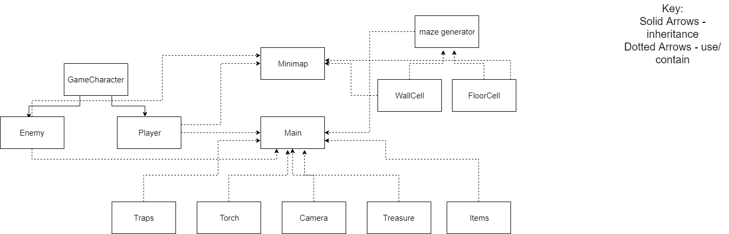Initial idea of what I believed the basic classes would be

## [6] UML Diagram Updated

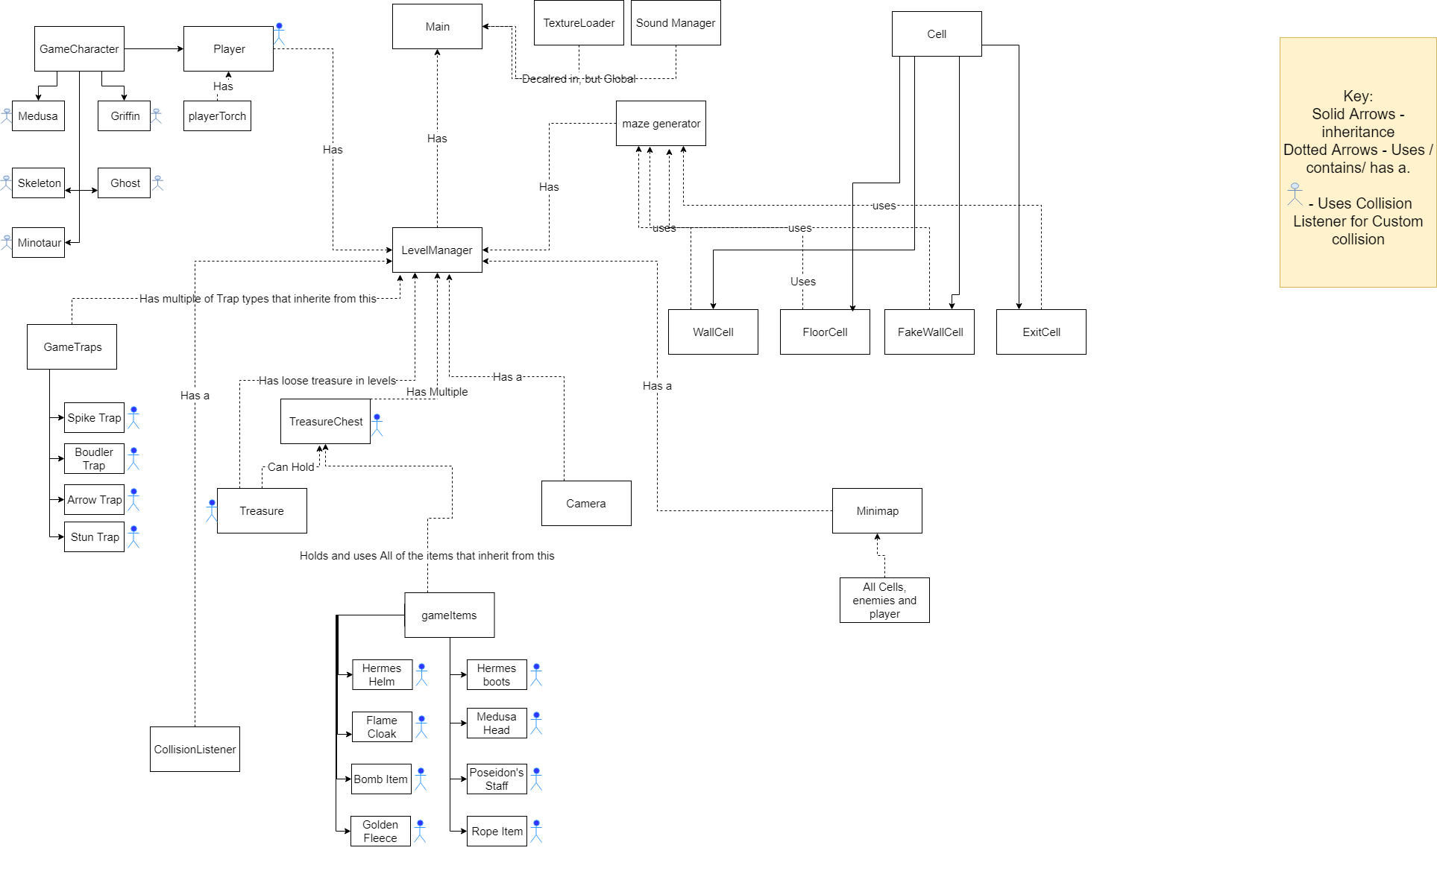UML diagram created after coming up with the idea for the majority of the content and implementing some of it. General Relations ships (i.e. passing some of the data from one class to another) excluded for clarity of diagram and readability. Functions and variables Excluded for the same reasoning.

## [7] UML Final

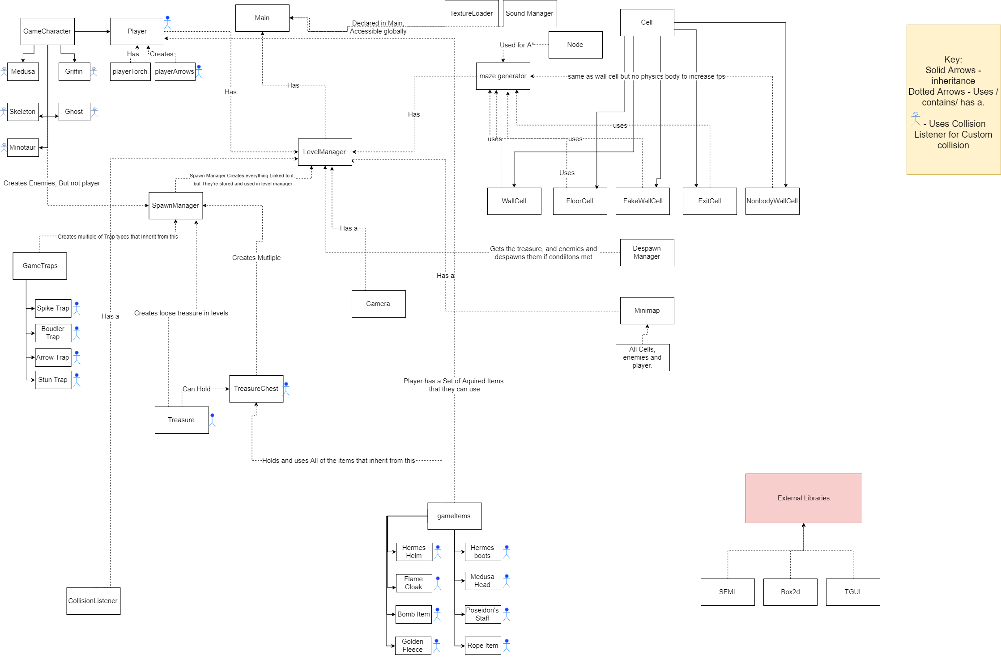UML containing the inheritance and ownership/ usage between all of the classes. Again, doesn’t show the general relationships and functions/ variables to maintain clarity and readability.

## [8]Class Diagram Showing Functions and Variables – Also Availble To view in Visual Studio and As Image in project Directory

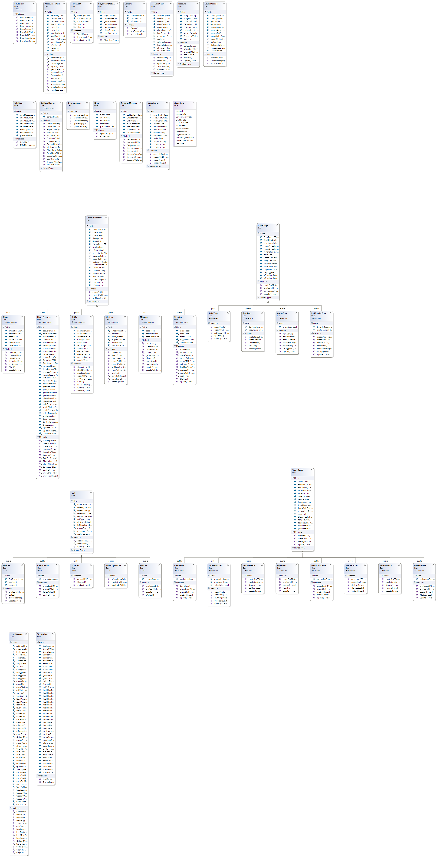



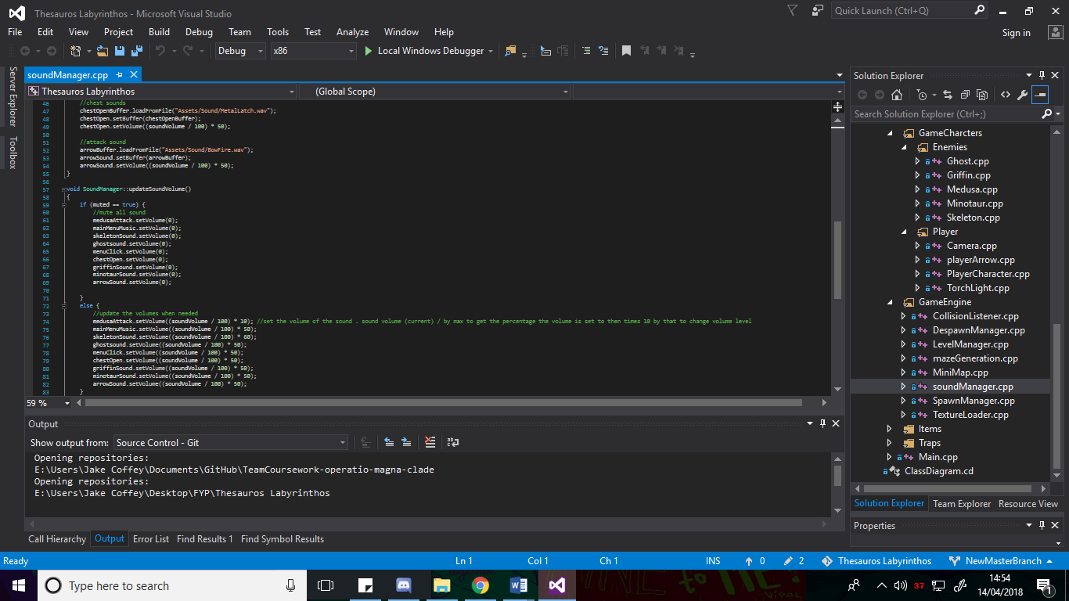[9] Sound Manager Update Function and sound load example

## [10] Original Menu Design

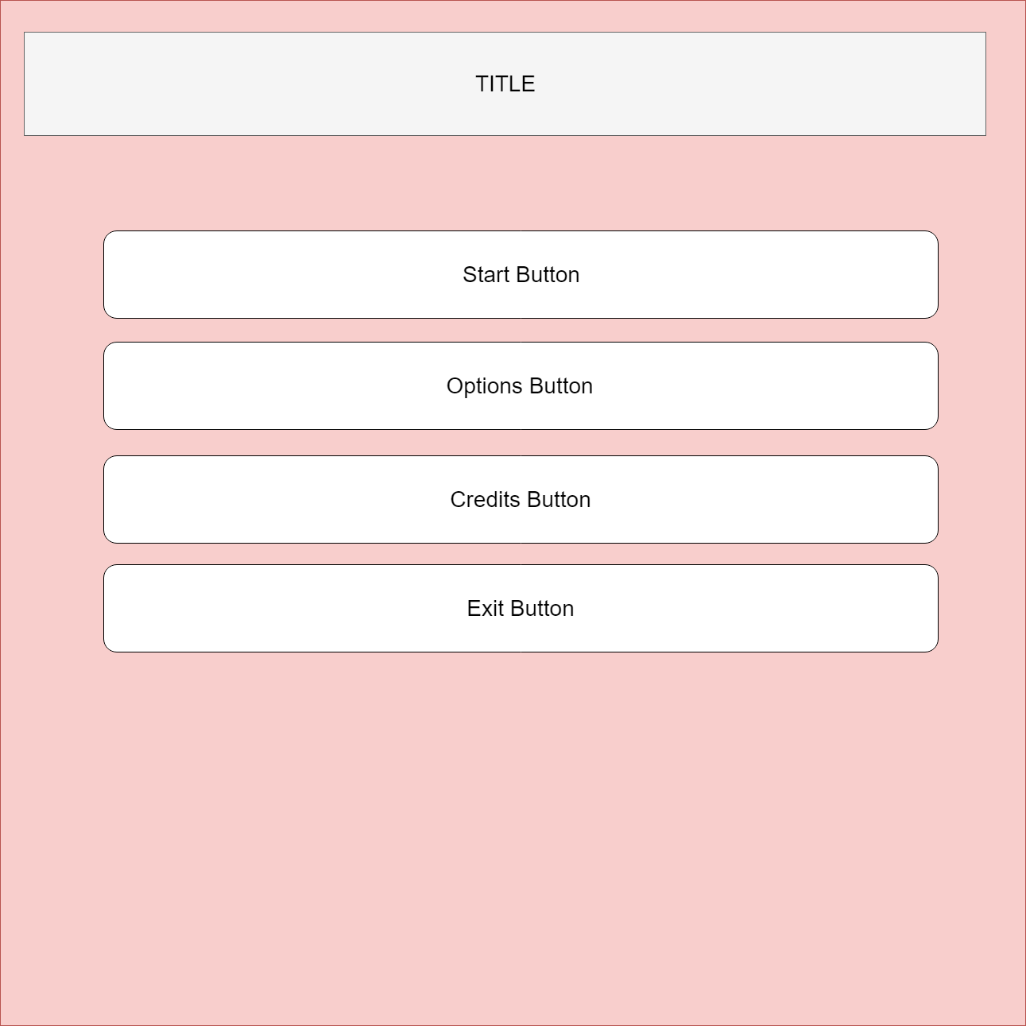

## [11] Final Menu Design

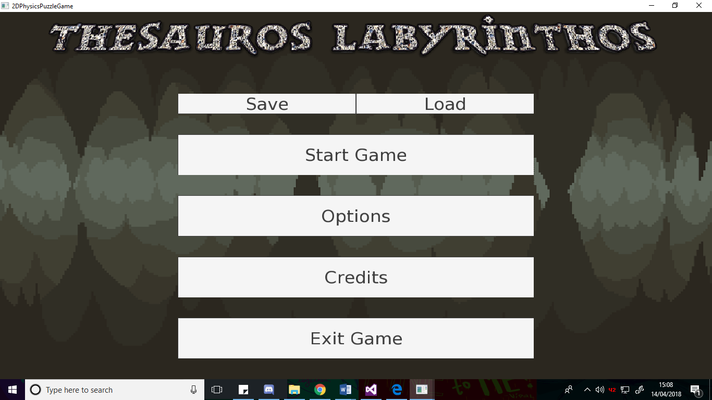

## [12] Shared_ptr example creating a skeleton enemy

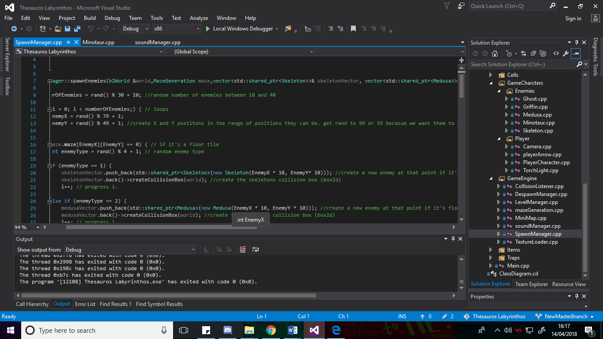

## [13] Shared_ptr iterator issue

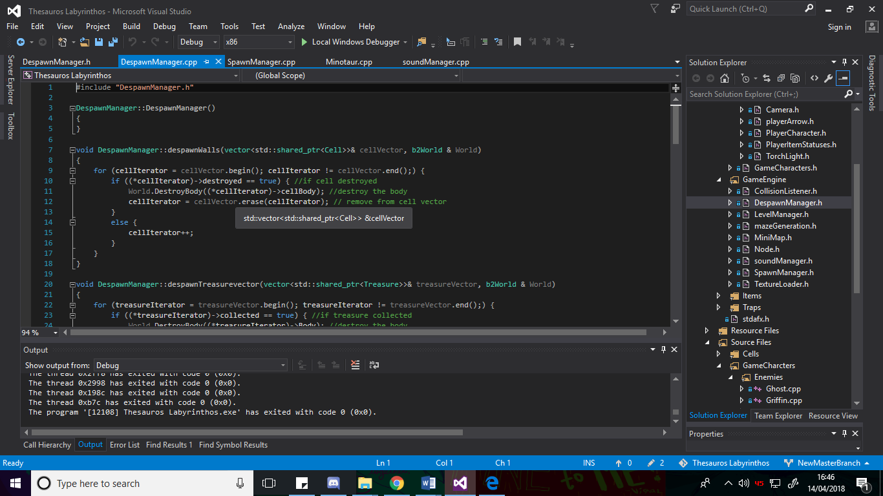

## [14] Spawn Manager function calls

## [15] Spawn Manager enemy creation example

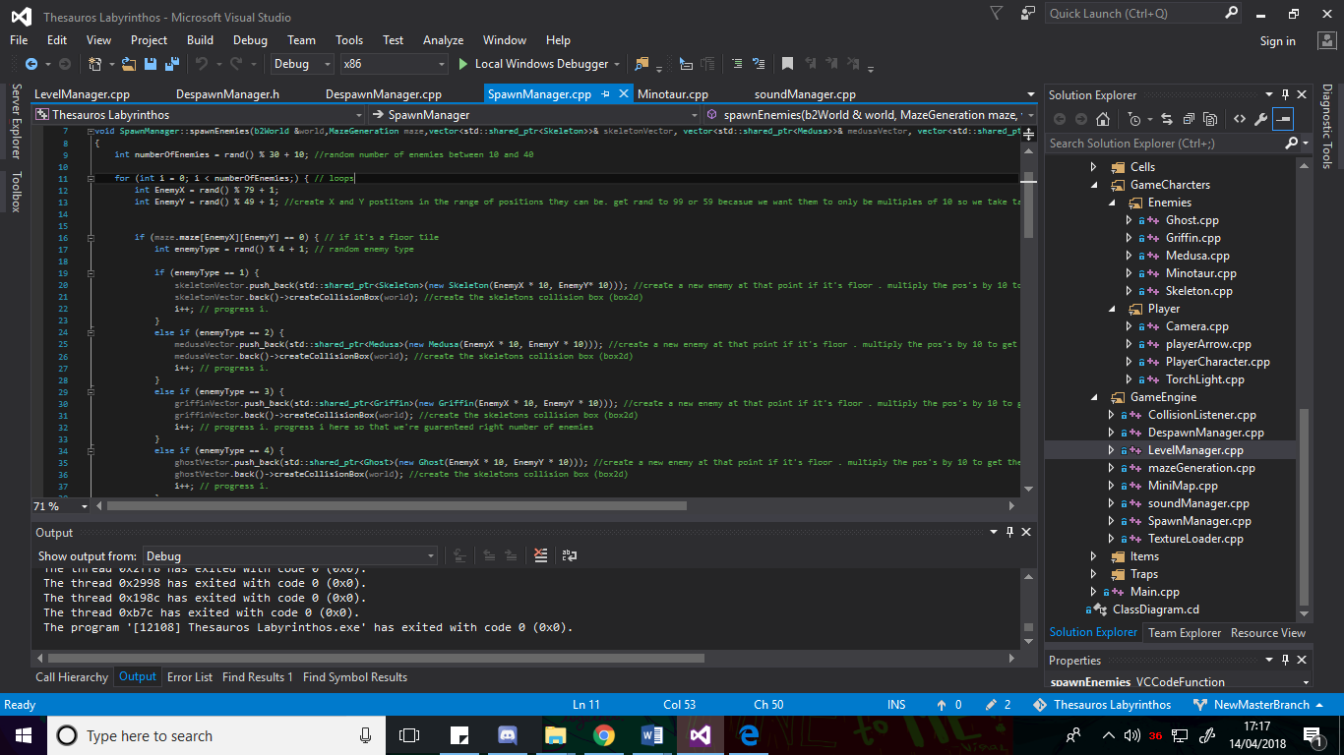

## [16] Despawn example

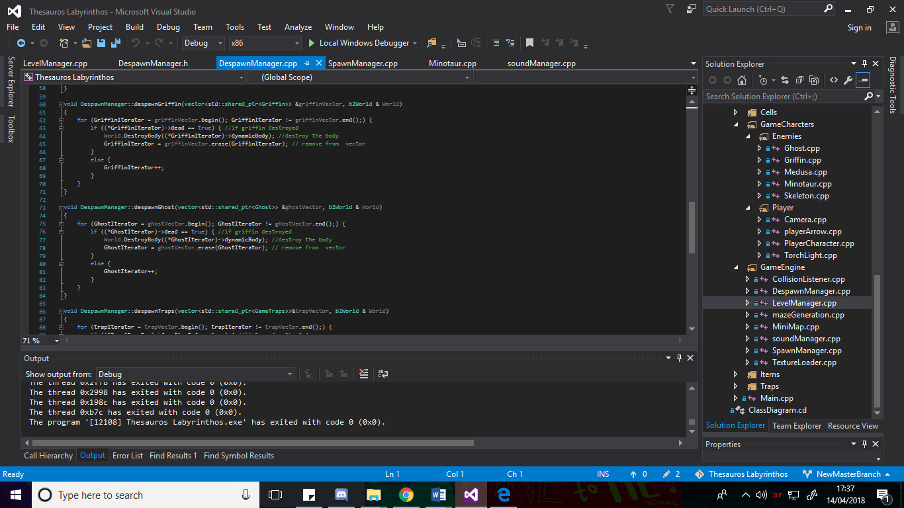

## [17] Box2d Body and Fixture creation example

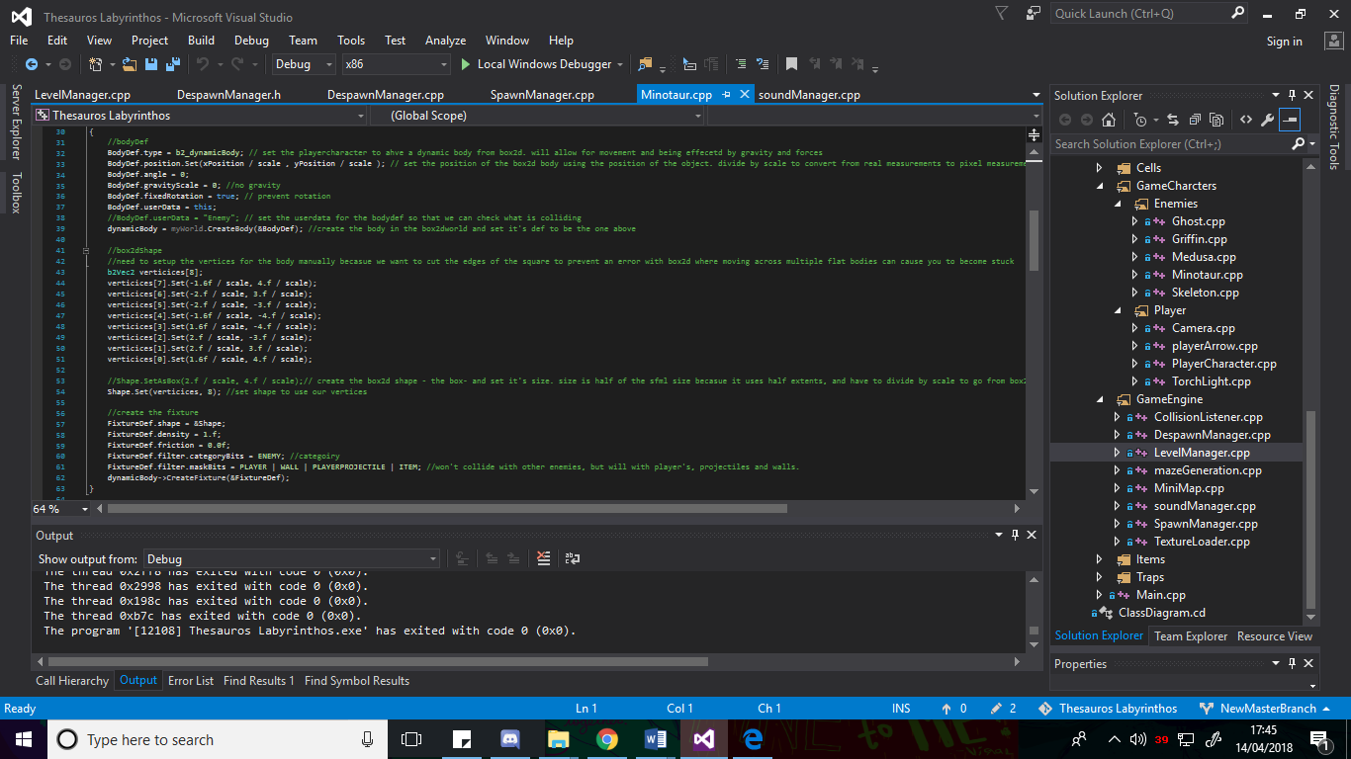

## [18] Collision Listener example

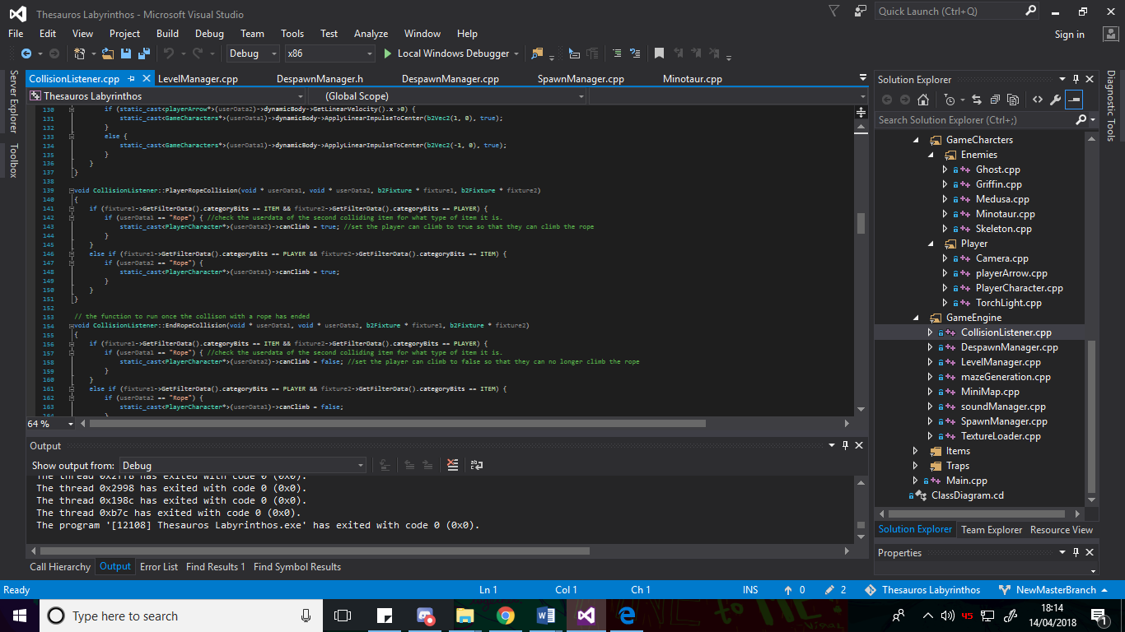

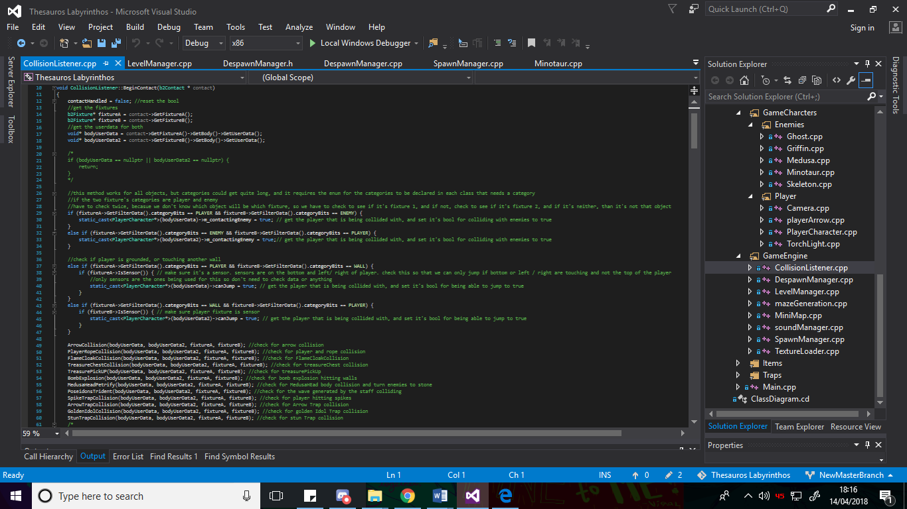

## [19] Finite State Machine

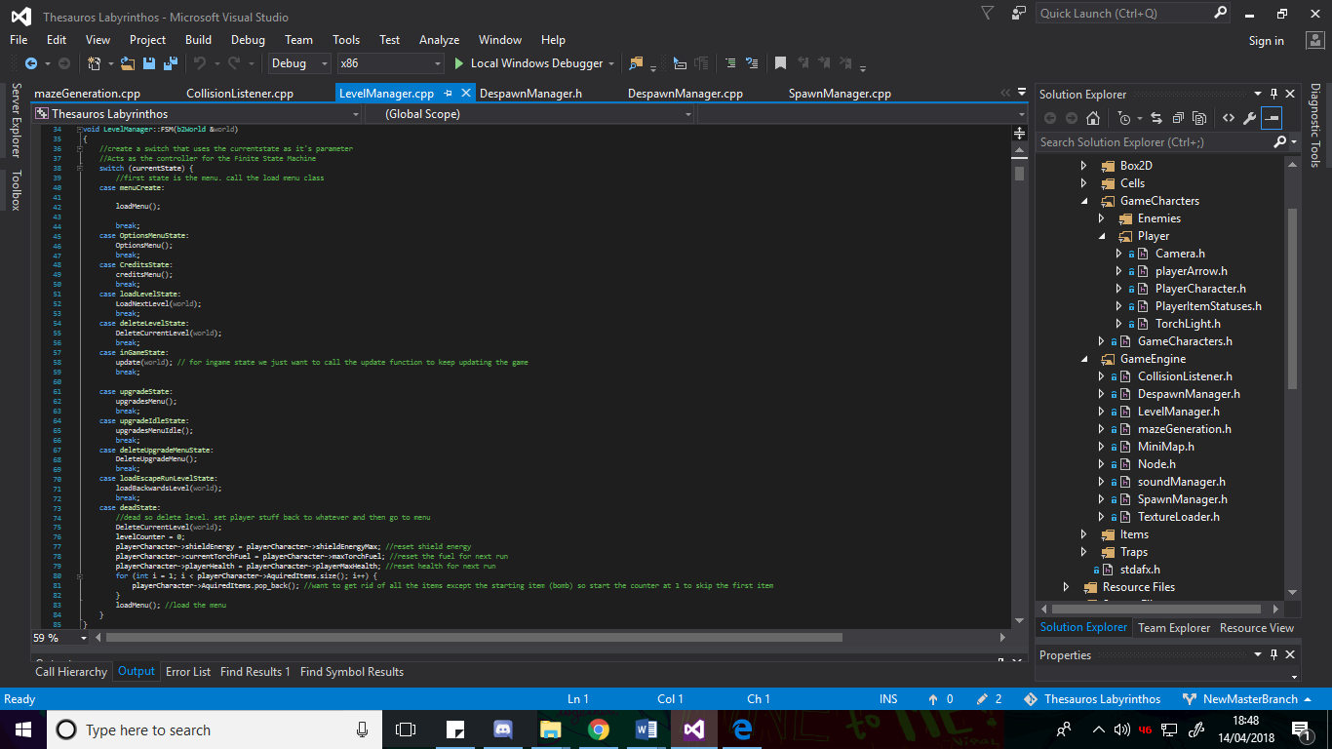

## [20] Signal Manager

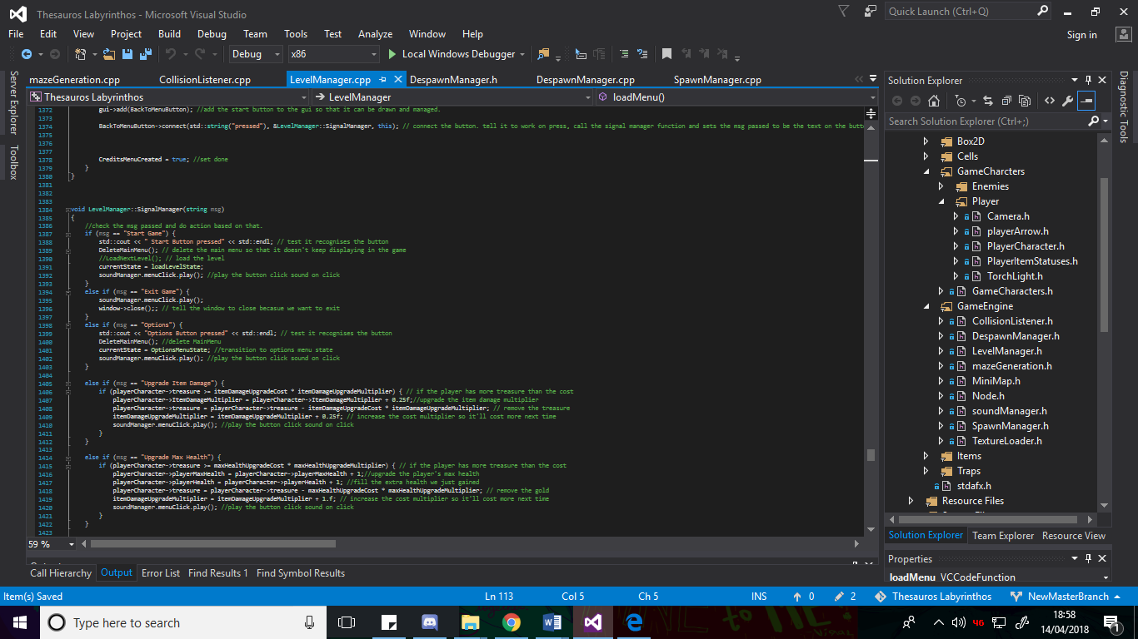

## [21] Updating upgrades GUI

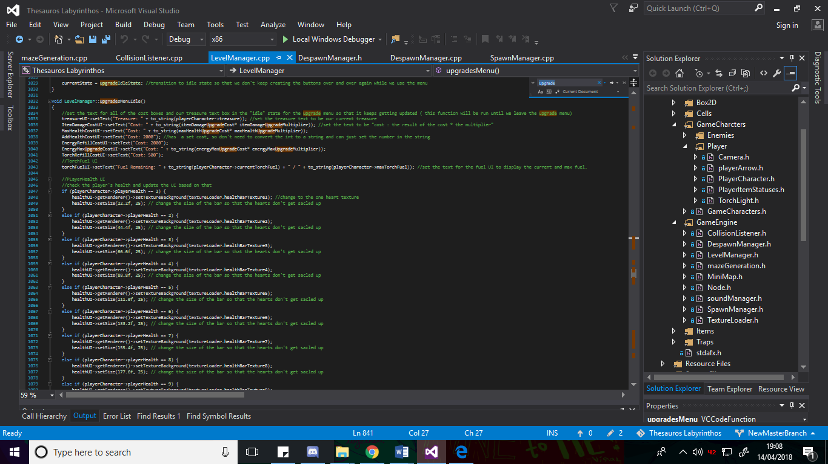

Upgrades available –

* Item damage.
* Player max health.
* Player current Health.
* Torch Max fuel.
* Torch current Fuel.
* Shield energy max.
* Shield energy current.

## [22] UI fuel bar updates

## [23] Item UI update

## [24] player update

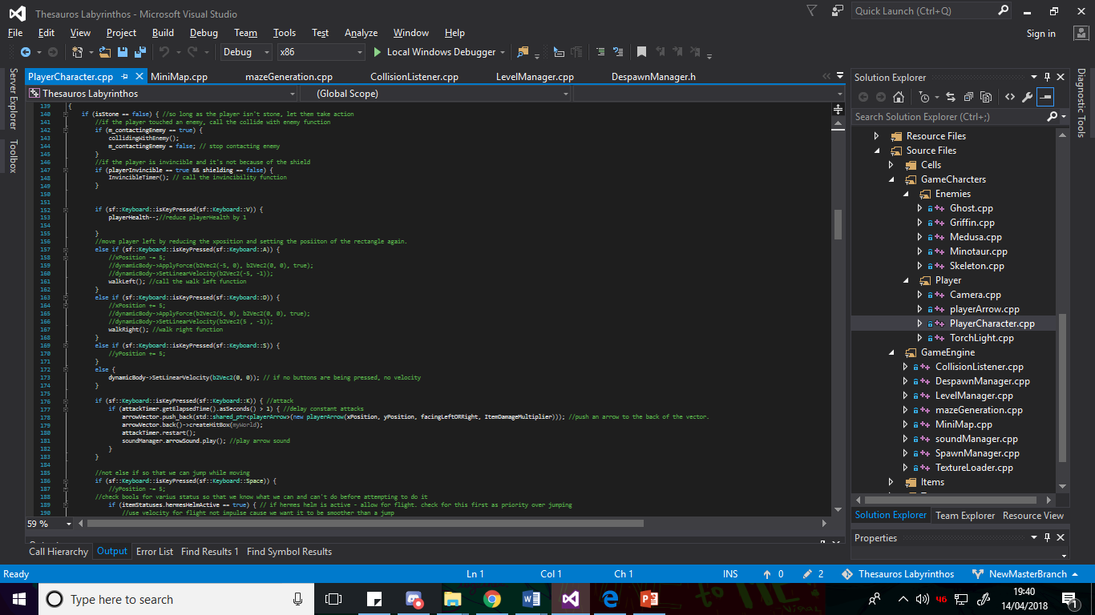

## [25] Player’s Fixtures

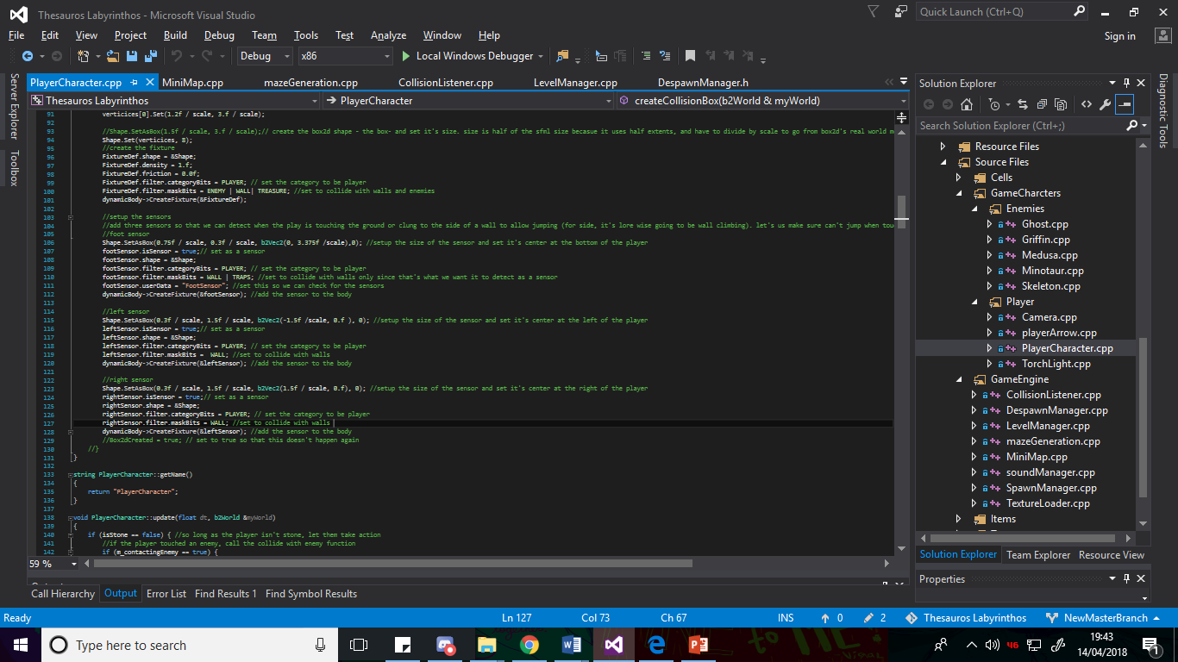

## [26] Torch

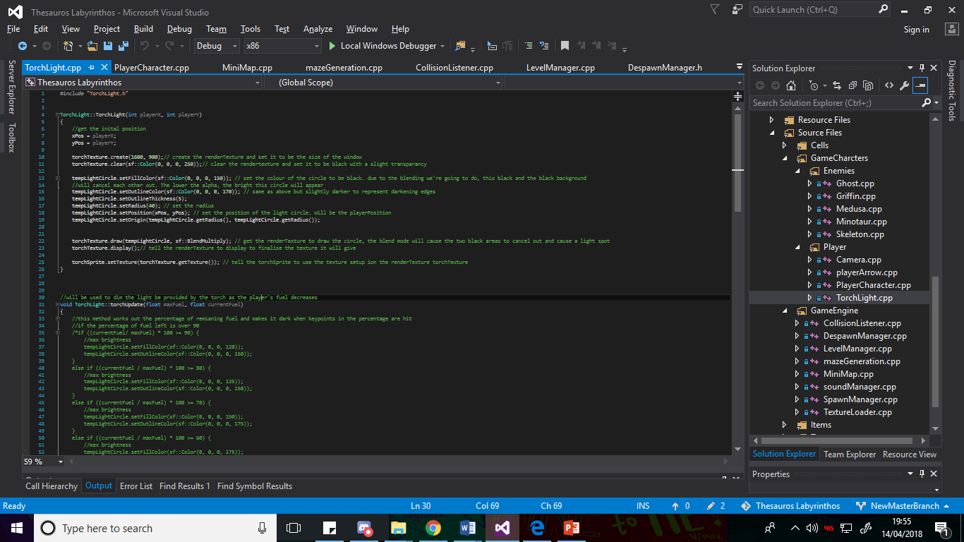

## [27] Torch Update

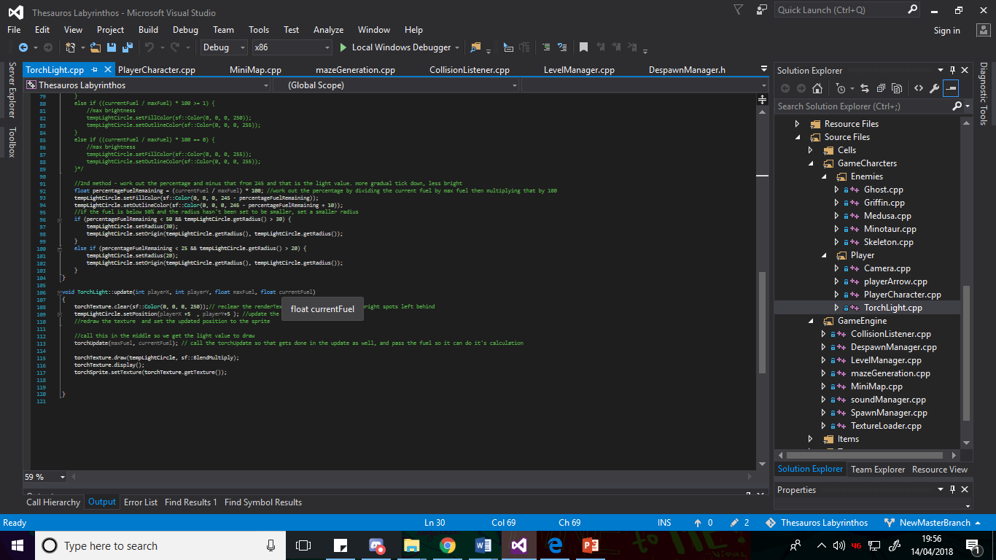

## [28] player animation example

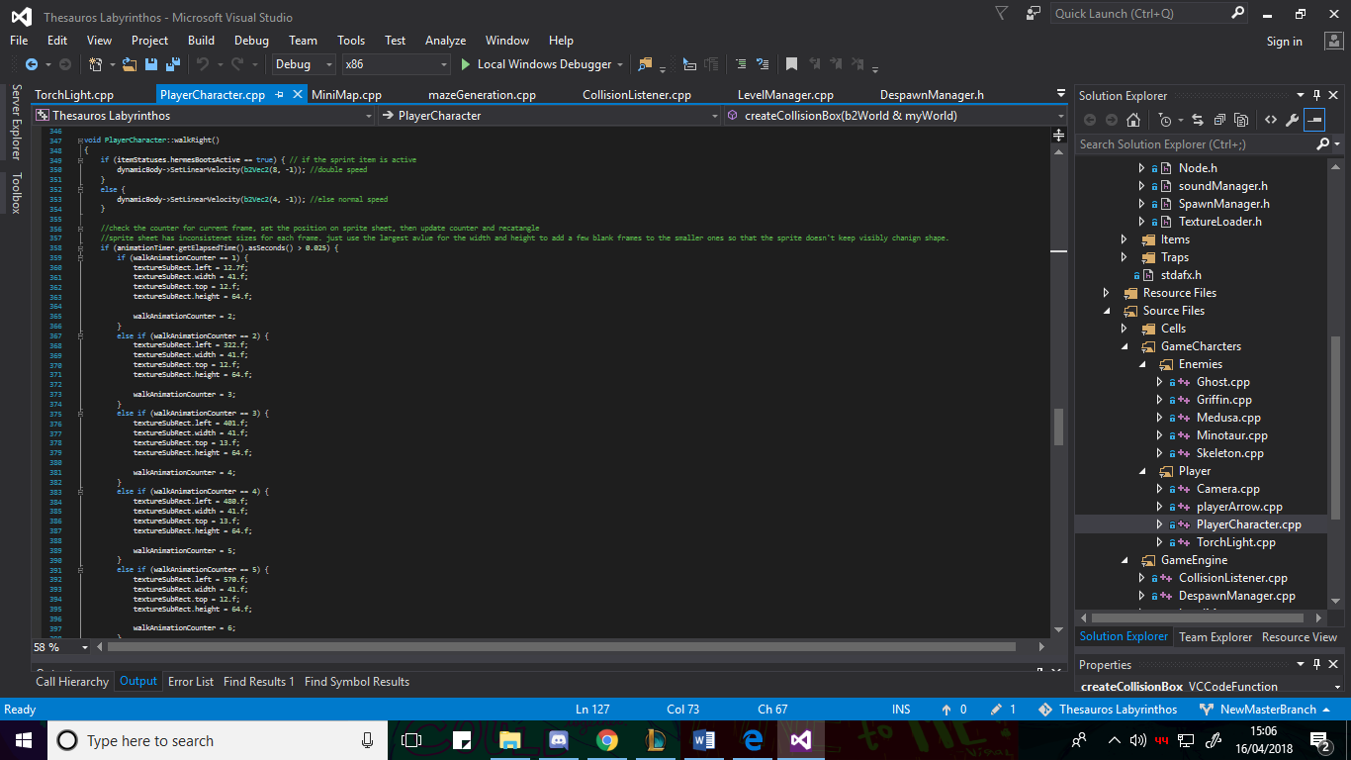

## [29] Flipped Animation Example

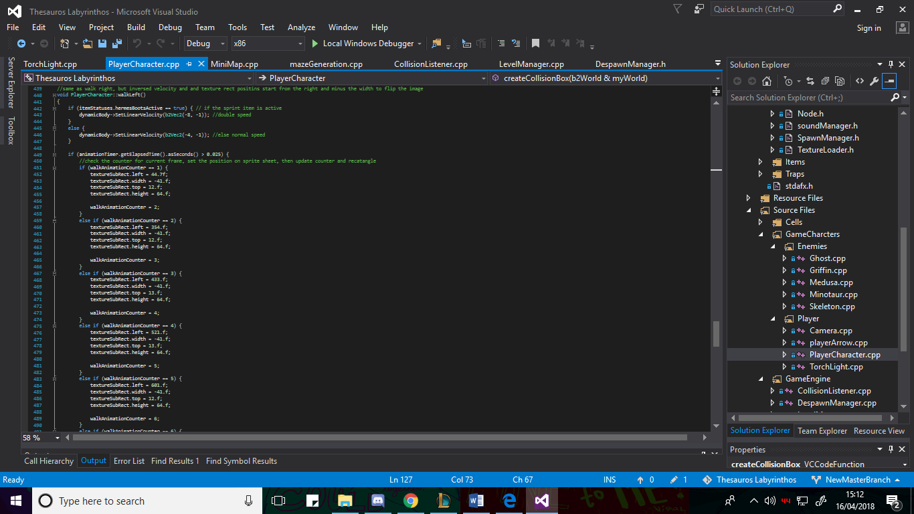

## [30] player spotted method

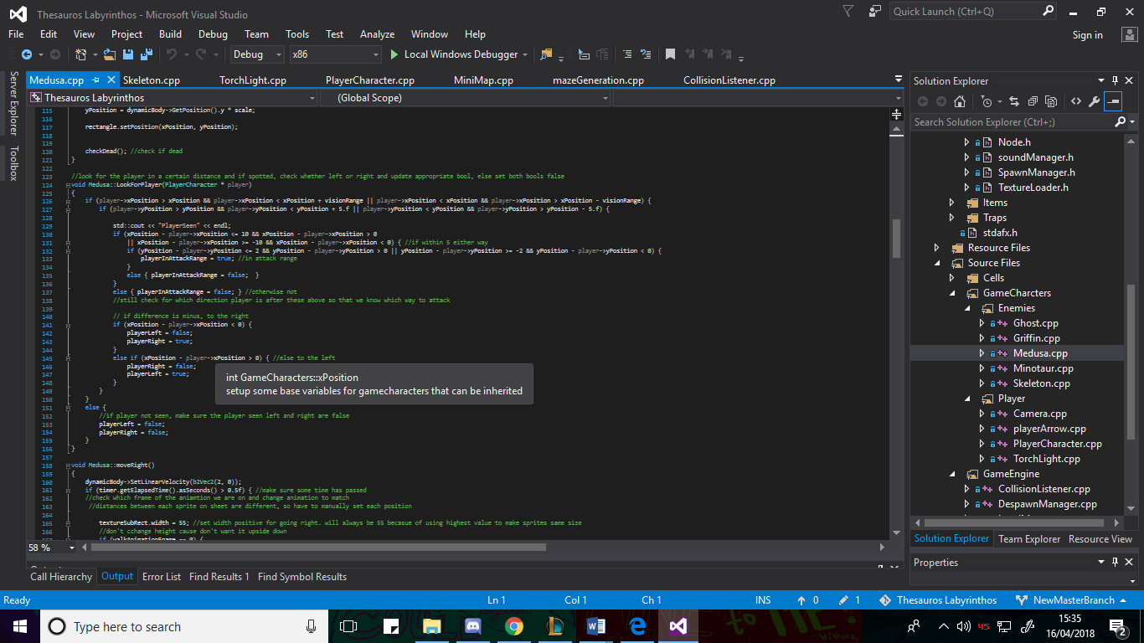

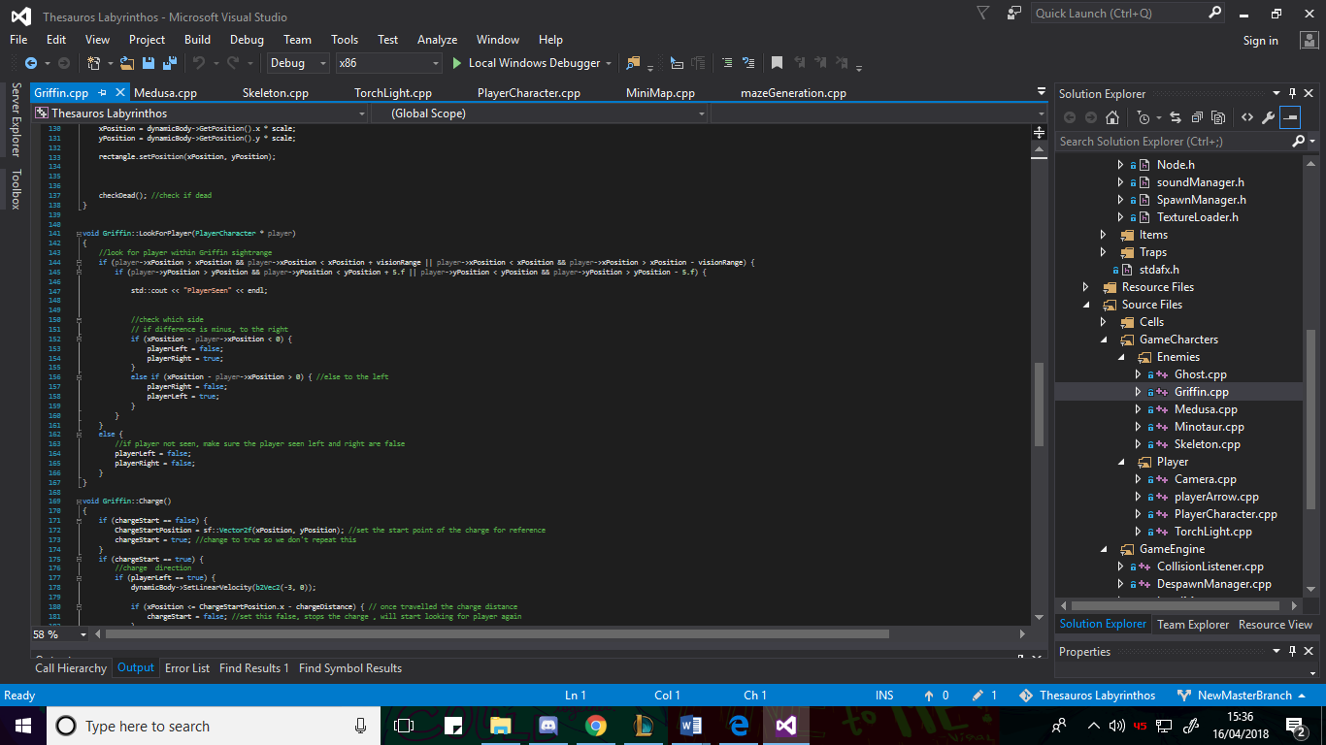

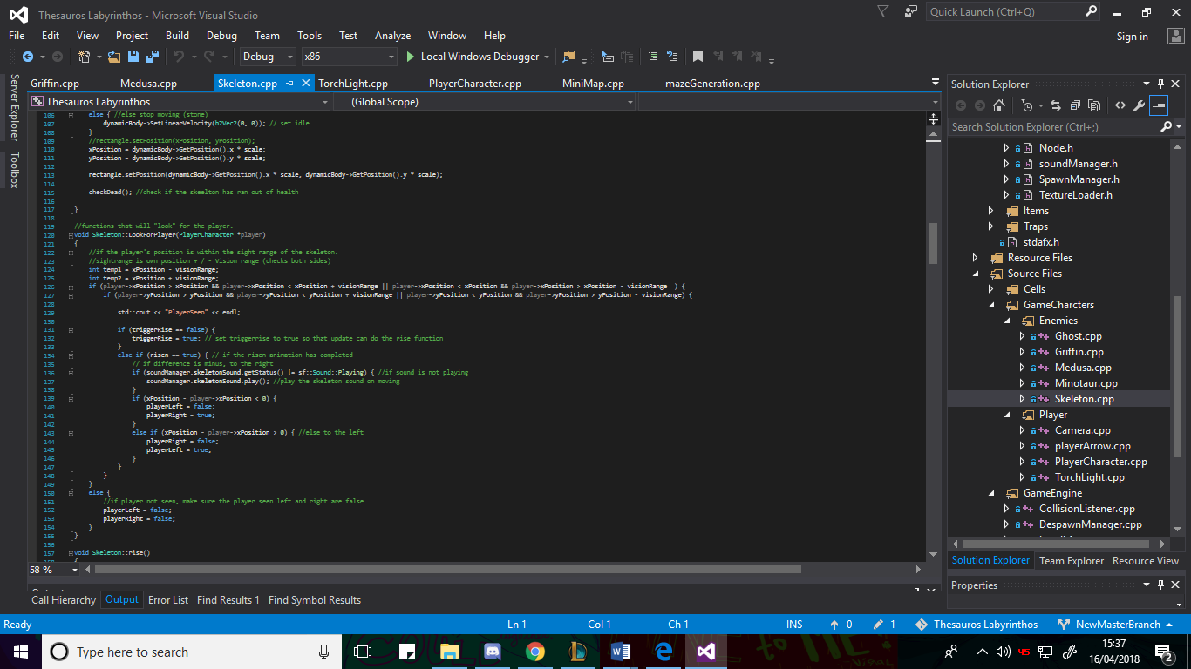

## [31] Spike Trap

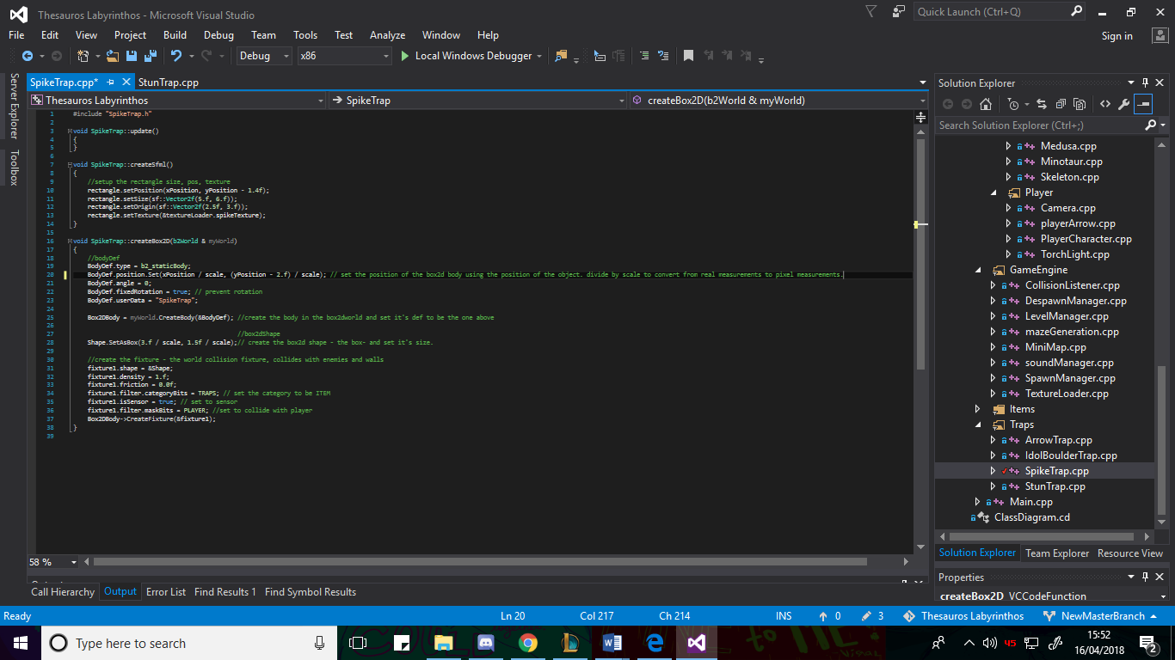

The position is set -2. f in the y to move the body to the top of the object texture to allow the player to walk through it, since the feet sensor of the player will go under it.

## [32] trap transforming example

Left shows the update that calls the arrow body creation/ transformation when triggered if not done yet or keeps updating the texture position if it has been done. Right shows the function getting the world from the already exiting body so that we can change the body, then changing the shape and size of the body, moving it 30.f to the left in the x axis, applying the velocity and setting the bool to true so it doesn’t transform again

## [33] Draw Culling

Due to the huge number of objects in the game, with the level along containing 1000’s of cells, a substantial portion of which have a texture and physics body, the performance of the game was being reduced because of the number of draws having to be done and the amount of textures being used every time the update was called. To minimise the amount of draw calls done and improve the performance, draw culling was implemented, where everything was checked to see if it was within the camera view radius of the player, and if it wasn’t, it wasn’t drawn. Despite this adding many loops and checks for each of the objects, these operations are far faster than draw operations, which are typically the slowest part of an sfml game, especially with textures. As such the performance was massively increased. Below an example of some of the vectors and objects being checked if they are within range before they draw them.

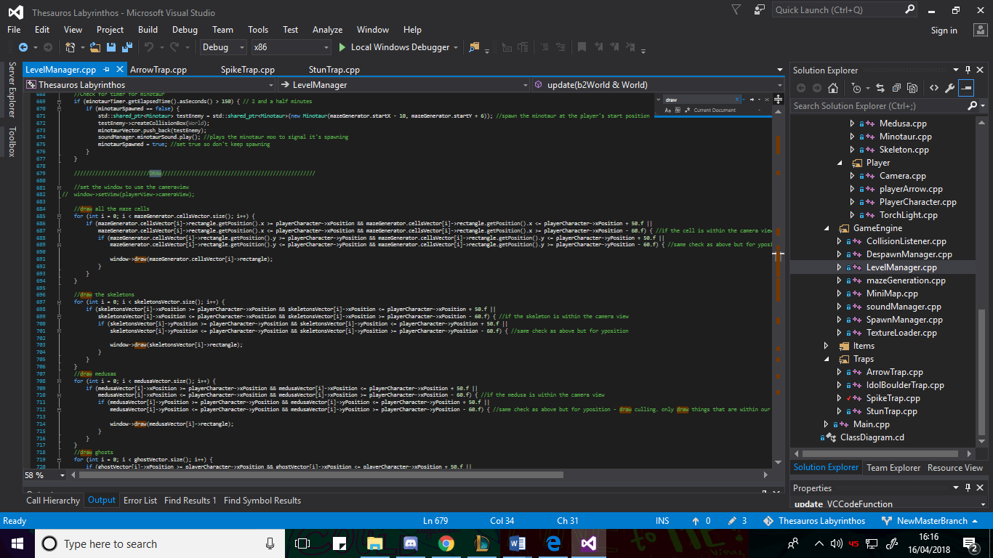

## [34] Item effects Details

* Golden Fleece – Heals the player when activated so long as they aren’t at their max health.
* Flame Cloak – surrounds the player with fireballs that follow them and damage enemies that run into them until their time runs out.
* Bombs – Destroy fake walls and damage enemies in their radius after a brief delay.
* Rope – Allows the player to climb up it.
* Hermes Helm – changes the player’s jump into flight briefly.
* Hermes Boots – Increases the player’s movement speed briefly.
* Medusa Head – stuns enemies in its hit box
* Shield - wasn’t an item in the vector, but when acquired, set a bool to true that allowed the player to press shift to use their shield energy to become invincible.
* Poseidon’s staff – Creates a wave that pushes enemies and damages them.

Treasure Chest also included –

* Hearts – give the player one health back if possible.
* Torch Fuel – give the player max torch fuel.
* Shield Energy – give the player max shield energy.

## [35] Treasure Chest Item Creation

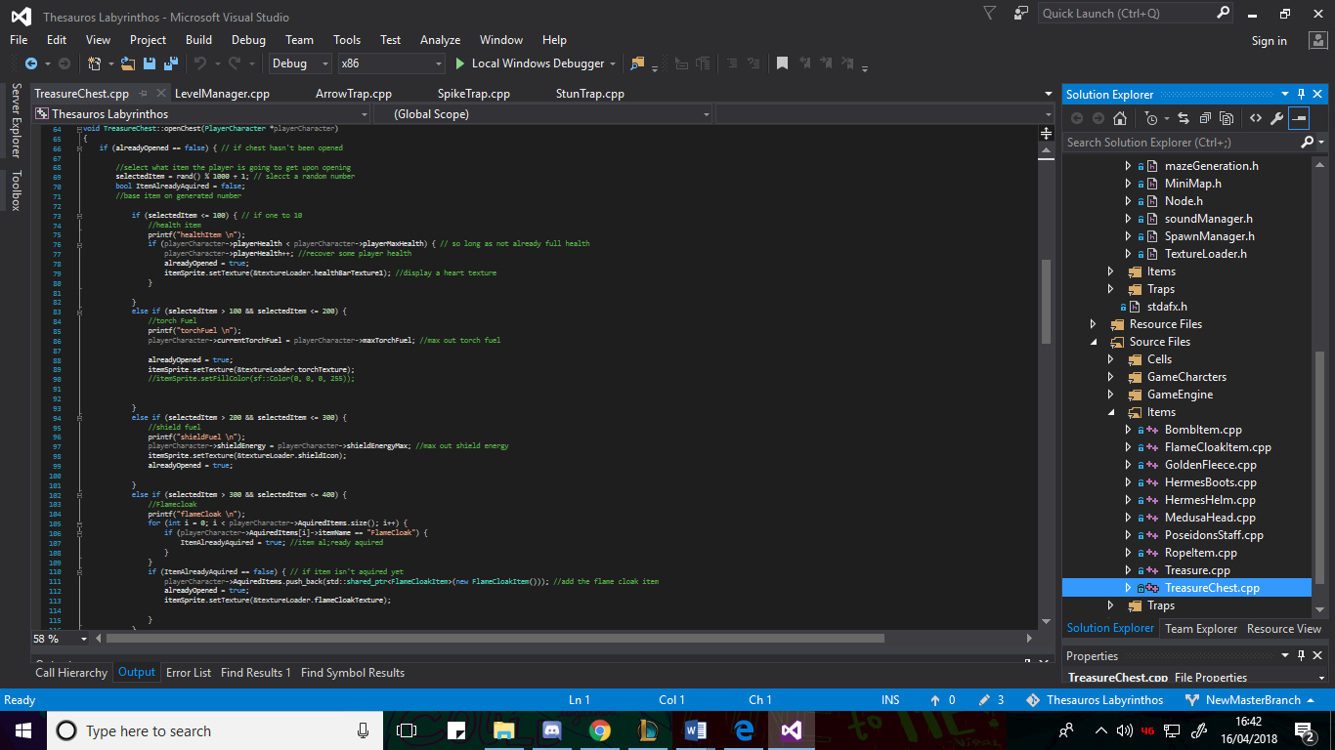

## [36] Items

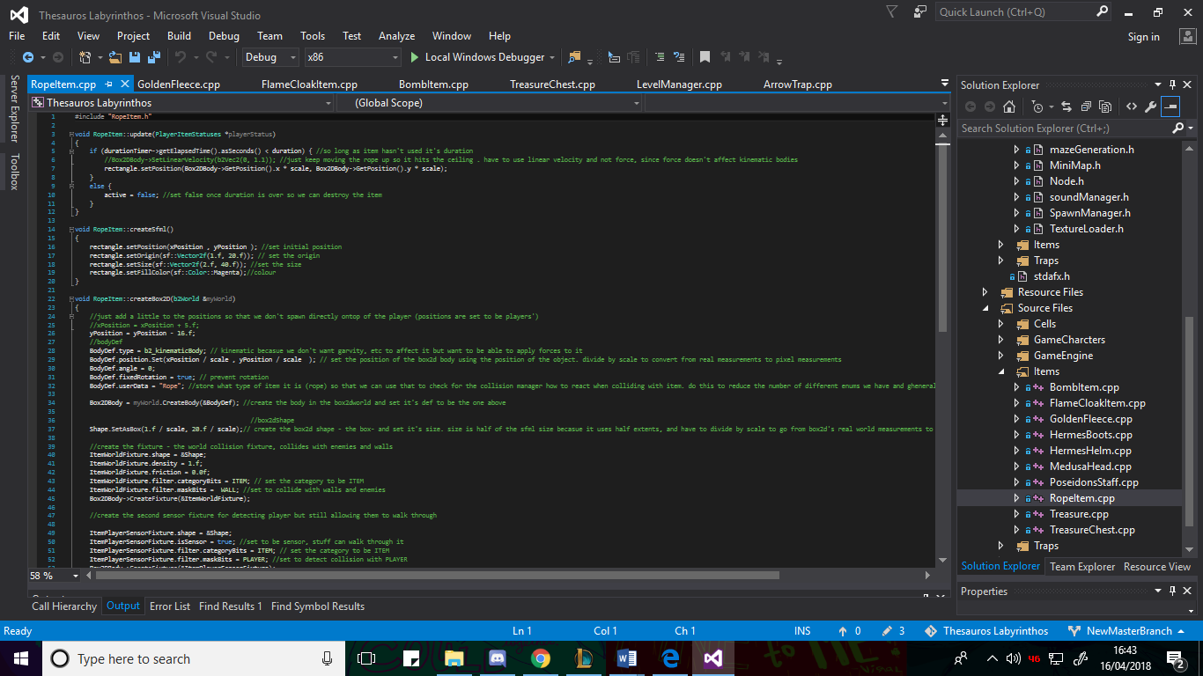

Below you can see the timer being used to check if the duration for the item has passed yet, if it hasn’t it carries on the effect, if it has, it sets it inactive.

Below you can see the player checking if the active item duration has run out and destroying it if it has. Also shows the current item counter being updated when the player presses q and what happens if it goes over the number of acquired items ( resets to first item).

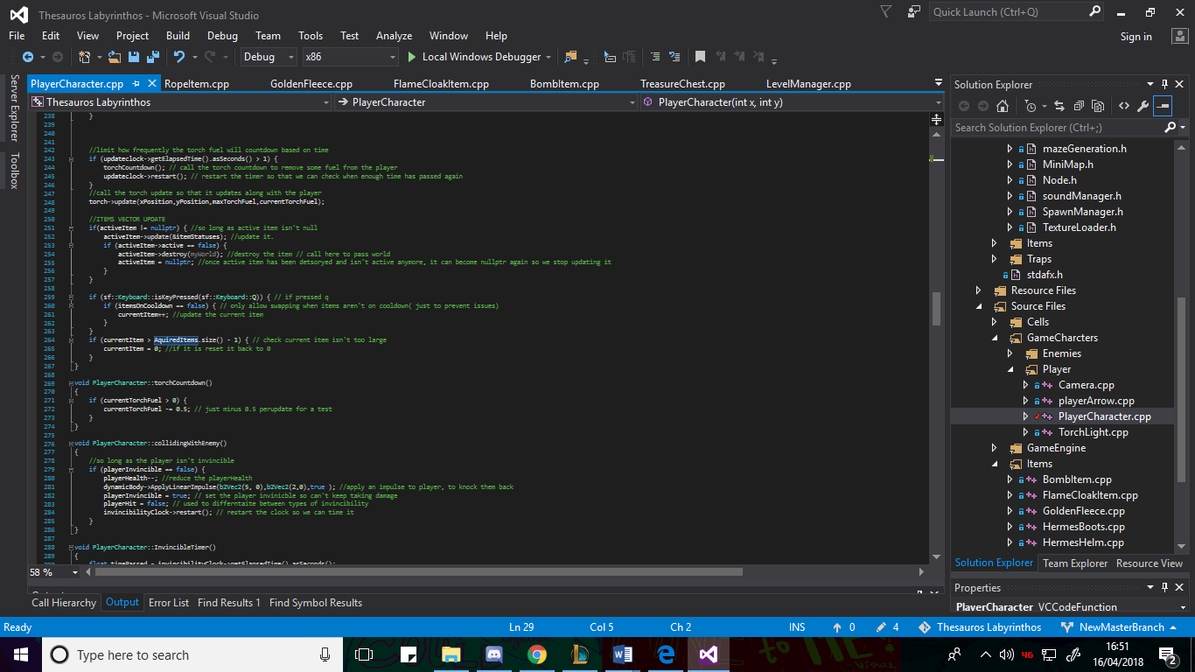

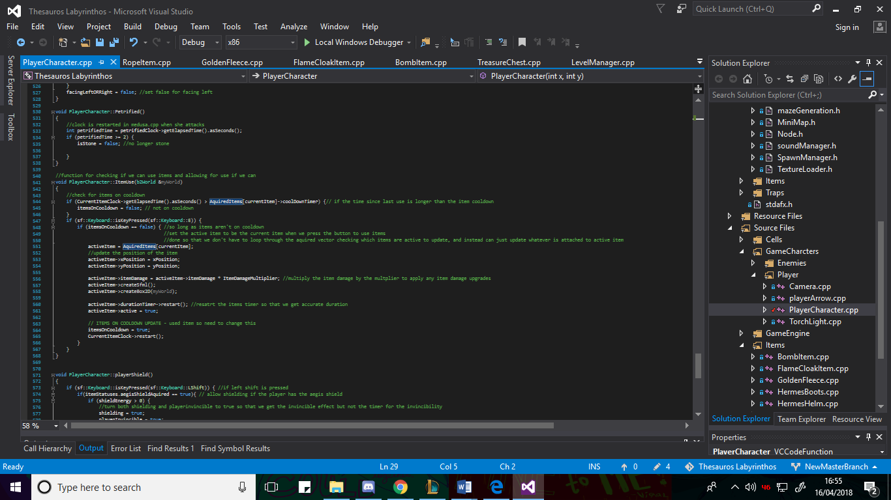

Below you can see the player item use function called in the update to check if the player is using items. It shows checking if the cooldown of the item has finished and setting a bool preventing item use to false if the time has finished. Then shows if the item use button is pressed and the items aren’t on cooldown, setting the active item to be an instance of the current selected item in the vector and creating it, then starting its clock.

## [37] Testing Plan

## [38] Test Log

The original testing plan for the project was to unit test all the different classes to ensure the functions worked as were intended. However, it soon became clear that this would not be an efficient or particularly easy way of testing the project, since the majority of the classes and functions heavily relied on both graphical or input elements from SFML or on physics elements and reactions based on box2d, all things that are either impossible to test with unit testing, in at the very least impractical and difficult to test with unit testing.

Instead Testing was done in two steps, these being play testing during the actual creation process of the product, and then black box testing once the project was complete or segments were finished.

Play testing, i.e. running the game and playing through it, was used to ensure that the coded sections were doing what was intended after they were made because of how quick, efficient and easy it was to do, with any graphical or input errors being immediately obvious when running the game because the input wouldn’t work, or the graphics would look wrong. Less obvious errors were also efficiently tested using this method by employing watch windows and breakpoints to go through the code and monitor what happened at each point, so that I could easily identify where the issues were.

Black box testing was then employed afterwards when completed to sweep through and ensure that everything did what was intended when working together.

The Test Log will contain a mixture of tests from the play testing and black box testing. Obviously if the problem was fixed in play testing, it didn’t occur again in Blackbox testing.

|  |  |  |  |
| --- | --- | --- | --- |
| **Test Case** | **Expected Result** | **Actual Result** | **Action Taken** |
| Player W key input | Nothing | Nothing | None |
| Player W Key Input While colliding with rope item | Climb the Rope | Climbed the Rope | None |
| Player D Key Input | Move Right, change animation frame | Moved Right, Changed multiple animation frames | Added a timer to check time since last animation frame change to prevent too quick animations |
| Player D Key Input | Move Right, change Animation frame | Moved Right, slower More controlled animation change | None |
| Player A Key Input | Move Left, Change Animation | Moved Left, Animated, facing wrong direction | Implemented inverse width animations as discussed in Implementation |
| Player A Key Input | Move Left, Change Animation, Face correct Direction | Moved left, animated, faced left | None |
| Player K Key Input | Create and shoot player arrow. | Player Arrow created and shot in direction facing | None |
| Player Space Key input touching floor | Player Jump | Player Jumped | None |
| Player Space Key touching wall side | Player Jump / Wall Climb | Player Jumped / Wall Climbed | None |
| Player Space Key in air | No Jump | Carried on falling | None |
| Player Space Key Input Hermes Helm Active | Flight | Player gradually Rose in flight | None |
| No input | velocity removed, player stops | Player stopped | None |
| Player Q Key Input Items not on cooldown | Current Item should change | current Item didn't change | Didn't register q key in time because it was checking something else. Swapped checks to check for input first. |
| Player Q Key Input Items not on cooldown | Current Item should change | Current Item changed | None |
| Player Q Key Input Items on Cooldown | No change | No Change | None |
| Player E key input | Active item should Spawn | Active Item Spawned | None |
| Active item duration ended | Active item should be destroyed and set to null, set cooldown | Destroyed and set null, cooldown set | None |
| Active item Golden Fleece | Player heal 1 heart | Player healed multiple hearts | Added a bool that gets sets false after healing once so that multiple hearts aren't healed |
| Active item Golden Fleece | Heal 1 heart | healed 1 heart | None |
| Active item Flame cloak | Fire spawn around player, follows player and hurts enemies | Followed player, hurt enemies | None |
| Active Item Hermes Boots | Movement speed should increase | Movement speed increased | None |
| Active Item Hermes Helm | Space should fly | Flew instead of jumped | None |
| Active item Medusa Head | Stun / petrify any enemies in range in direction facing | Enemies petrified | None |
| Active Item Bomb item | create bomb, that after delay should destroy fake walls around it and hurt enemies | Correct behaviour | None |
| Active item Rope item | Rope should be created. Player should be able to climb it using W key | Correct behaviour | None |
| Active Item Poseidon’s Staff | Wave should spawn in front of player , dealing damage and pushing enemies away | Correct behaviour | None |
| Item Sprites created in appropriate positions and animate | Item Sprites created in appropriate positions and animate | Item Sprites created in appropriate positions and animate | None |
| Player collided with enemy | lose life, temporary invincibility to prevent losing all life immediately | lost life, temporary invincibility to prevent losing all life immediately | None |
| Player Torch Update run | player should lose some fuel; torch brightness should dim slightly (probably not notable unless waiting for a while due to being percentage based) | Player lost some fuel, torch dimmed by a fraction. | None |
| Player Torch follow player | torch should follow the player, slightly off centre | Correct behaviour | None |
| Player camera | Should follow the player and display a zoomed in view of the maze, giving sight of a small area around the player | Correct behaviour | None |
| Player left Shift input with shield | blue bubble around player appears, invincible , energy drains | Correct behaviour | None |
| Player left Shift input with shield, no energy | nothing | Correct behaviour | None |
| Player left Shift input, no shield acquired | nothing | Correct behaviour | None |
| Player petrified | No actions possible | couldn't act, but velocity carried on, slid into enemy and took damage. | Petrified check was preventing velocity removal. Added velocity removal when petrified |
| Player petrified | No actions possible, no sliding | Couldn’t act, didn’t carry on sliding | None |
| Enemies see player within their range | Player should be spotted when within the range between the enemies’ position + / - sight range | Player spotted within correct range | None |
| Enemies Reaction to player spotted | Skeleton should rise and move towards player, Medusa should move forwards into range and try to petrify, Griffin should charge in the direction the player was spotted for a random amount of time with increased speed, can't change direction until charge is done | All enemies acted appropriately | None |
| Ghost test | Shouldn't react to player at all, should keep generating random points to move to and going there | Kept generating points and moving to them, sometimes teleported. | Axis position was being reset when didn't need to move along relative axis. Removed line that did that. |
| Ghost test | Shouldn't react to player at all, should keep generating random points to move to and going there | Proper movement behaviour | None |
| Minotaur Test | Should spawn after 2.5 minutes | Spawned on time | None |
| Minotaur Test | Should generate a path to the player every 5 seconds | Path updated on time, followed path | None |
| Enemies Animation | All enemies should have animation that changes after a timer when moving | Animation worked fine | None |
| Griffin Wander behaviour | when player not spotted and charging, should wander a random genned distance before changing direction | Correct behaviour | None |
| Spawn Manager | spawn manager should spawn a random amount of each object (not maze cells) into level within ranges | Correct behaviour | None |
| Despawn Manager | Should destroy and remove object from vector when collected, destroyed or dead | Correct behaviour | None |
| Treasure | each piece of loose treasure should random gen a value under 100 and create its colour based on the number | Correct behaviour | None |
| Treasure Chests | When player walks over a chest, should gen a number and give the appropriate corresponding item. Items should be added to the acquired item vector if not already received | All numbers gave correct items. Items pushed into vector if not acquired yet. Correct Behaviour | None |
| Treasure Chests | Once Opened, should change texture | Correct behaviour | None |
| Collision Listener listens to all collisions and runs appropriate methods if needed | Collision Listener listens to all collisions and runs appropriate methods if needed | Correct behaviour | None |
| Texture loader should load all textures successfully and be accessible form all files with textureloader.h included | Texture loader should load all textures successfully and be accessible form all files with textureloader.h included | Correct behaviour | None |
| Textures | All textures should get set over relevant item correctly | Correct behaviour | None |
| Sound Manager | sounds loaded properly, can be muted and turned down, sounds play in appropriate places they’ve been used | Correct behaviour | None |
| Maze generation | Algorithm digs through the maze using random directions to choose which cell to dig into next. Maze array is updated with the correct ints for the cells types | Correct behaviour | None |
| Maze generation | End of generation takes the output and creates the appropriate cell type and adds it the cells vector for drawing and updating | Correct behaviour | None |
| Maze generation | Fully surrounded wall cells correctly filtered out and not created as wall cells to reduce performance impact | Correct behaviour | None |
| Levels saved | Randomly generated levels are saved so they can be used in the retreat run through the maze | Correct behaviour | None |
| Retreat run | Levels are reloaded correctly and look the same as first time through them | Correct behaviour | None |
| Save And Load | Data gets output to txt file on pressing save and correct data is read from the txt file on pressing load | Correct behaviour | None |
| All menu Buttons work as intended | All Menu buttons work as intended | Correct behaviour | None |
| Gui displays correct information and gets updated | Gui displays correct information and gets updated | Correct behaviour | None |
| Options Menu | Sound slider and mute button correctly update the sound volumes | Correct behaviour | None |
| Level Manager | Game states are correctly handled and all lead to appropriate functions and events. Transitions between states are correct | Correct behaviour | None |
| Level Manager | Level deletion and menu deletion functions completely delete objects, not leaving anything unintended on the screen | Correct behaviour | None |
| Level Manager | Level Creation fully creates a maze, places the player, creates enemies, traps, treasure, and treasure chests | Correct behaviour | None |
| Level Manager | Exit properly created and takes the player to the next level | Correct behaviour | None |
| Level Manager Update | Correctly draws and updates all objects and elements of the game that are used during gameplay | Correct behaviour | None |
| Level Manager Update Draw Culling | Only draws objects within view of the player's camera, everything else isn't drawn | Correct behaviour | None |
| Upgrades and upgrade menu | Buttons correctly upgrade the relevant stat and the costs get updated. Correct amount of treasure removed from player | Correct behaviour | None |
| Upgrades, not enough treasure | Buttons shouldn't upgrade the stat or remove any treasure | Correct behaviour | None |
| Minimap draws the white and red rectangles in another view to show the local area | Should show about twice as much as the camera (estimate, not actual measurement). White rectangles represent walls and red enemies. Should get updated when an enemy moves or wall blown up | Correct behaviour | None |
| Trap triggers | Traps should be triggered when hitting the body/ taking the idol/ landing on top of the spikes | All traps triggered in correct ways | None |
| Trap Effects | Spikes should kill if landing on top of them but can be walked through, arrow trap should create an arrow that is shot at player, idol should spawn a boulder after a delay and stun should stun the local area | Correct behaviour | None |
| Trap Positions | All trap triggers should be spawned on the floor. Secondary effects should be spawned nearby and not in walls | Appropriate spawns | None |
| Trap animations and textures | should animate for medusa stun trap while all should have appropriate textures for texture loader | Correct behaviour | None |
| Player arrows should fly straight ahead, unaffected by gravity | Player arrows should fly straight ahead, unaffected by gravity | Correct behaviour | None |
| Player arrows should despawn on collision with appropriate objects | Player arrows should despawn on collision with appropriate objects | Despawned with certain objects. Collided with unintended objects | Updated fixture filters to prevent collisions with the unintended objects |
| Player arrows should despawn on collision with appropriate objects | Player arrows should despawn on collision with appropriate objects | Despawned on hitting enemy or wall. No collision with other objects | None |
| Player Arrows should damage enemies | Player Arrows should damage enemies | Correct behaviour | None |

## [39] Gantt Chart and Project management

### Original Gantt Chart plan:

The plan below began from week 7 of university (the first submission hand in week) and detailed the original idea of how long each section would take to implement.

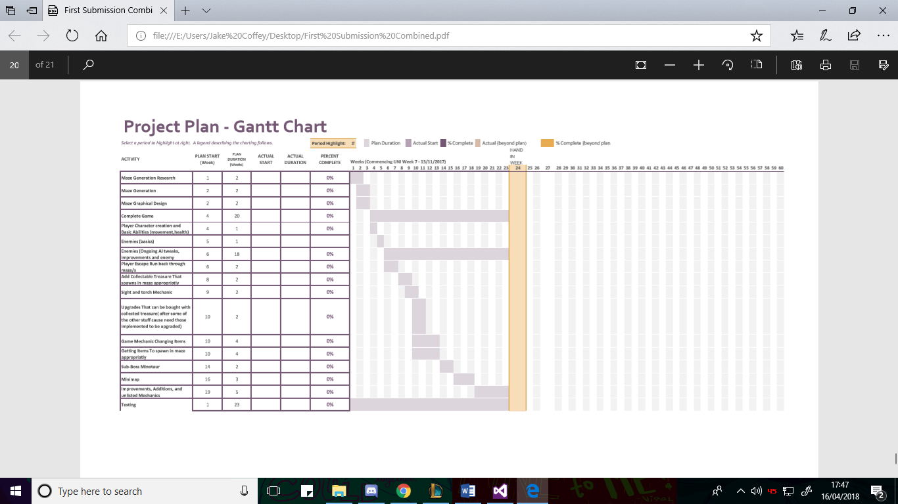

### Actual Gantt Chart:

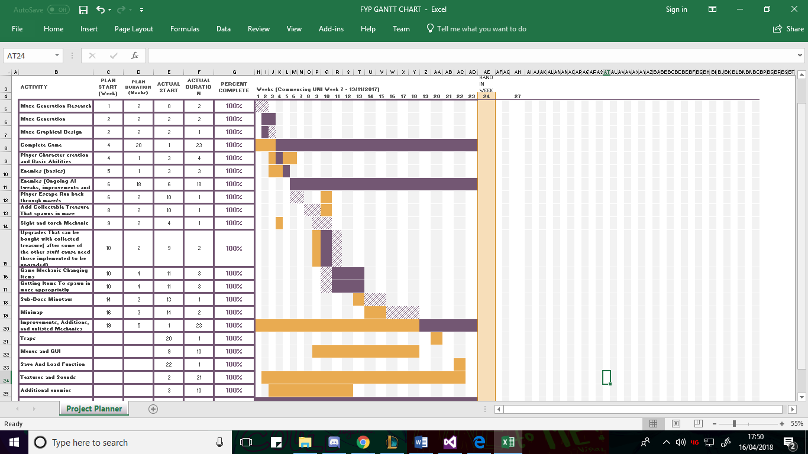

## BackUps – GitHUb

Whenever an element of the Project was successfully added or updated, or something was fixed in the project, the entire project was backed up to git hub first through the in-built visual studio to github connection and creating a repository for the final year project. It was frequently backed up here in case something went wrong with either my hard drives or pc so that there was another copy of the project somewhere to restore any lost work. It was also backed up to github to negate the risk of breaking the game, as any changes made to the main copy of the project that caused errors that couldn’t be solved or broke something that couldn’t be figured out could be removed by using the cloning the github version of the project, or if the problem had been uploaded to github, restoring the repository to an earlier version, providing a safety mechanism for the project.

Below the Github and example commits can be seen and a link to the github has been provided.

## GITHUB Link:

<https://github.com/lordhatnoop/FinalYearProject/tree/NewMasterBranch>

## BackUp – USB

Another backup was made to an external drive frequently just in case anything happened to the github backup. This backup was made to a USB drive and can be seen below.

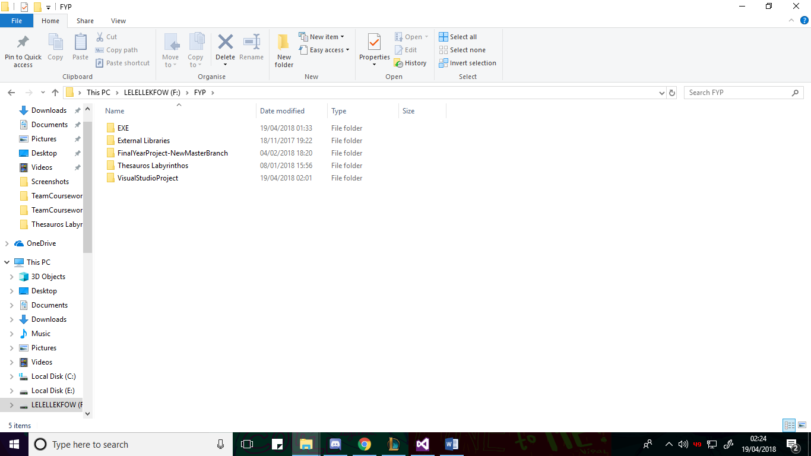

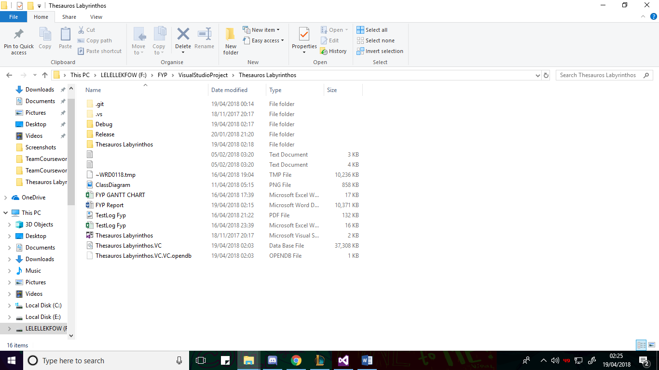

## Credits

To try and negate the risk of someone being offended by the use of their sprites or sounds being used in the project, only textures and sounds that were clearly stated to be available for use of some kind, typically educational/ personal use or credited use, and then the website/ people were credited for them in a credits menu available from the main menu.

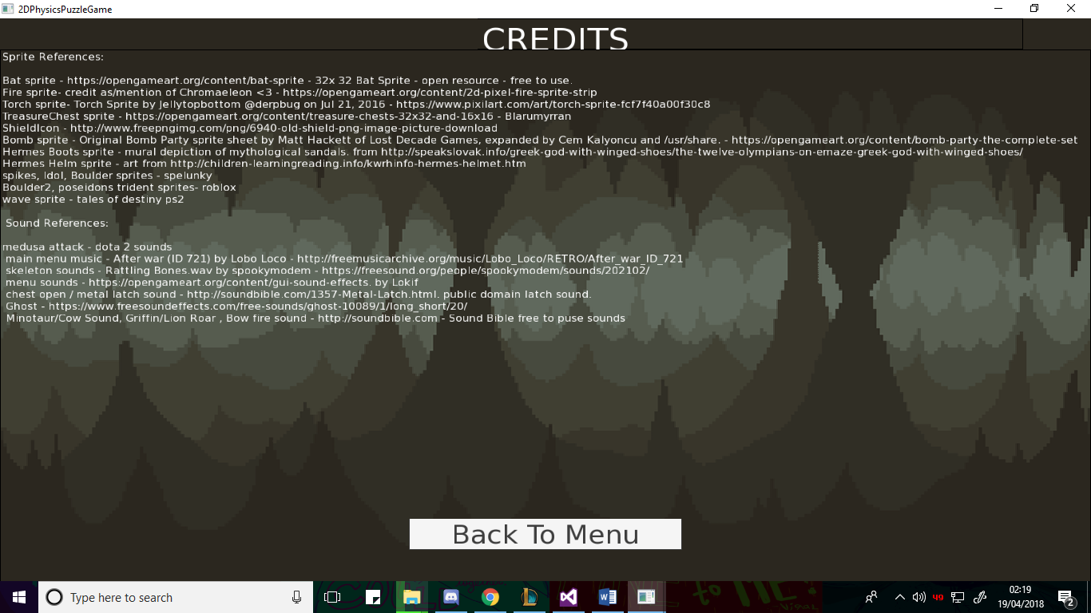

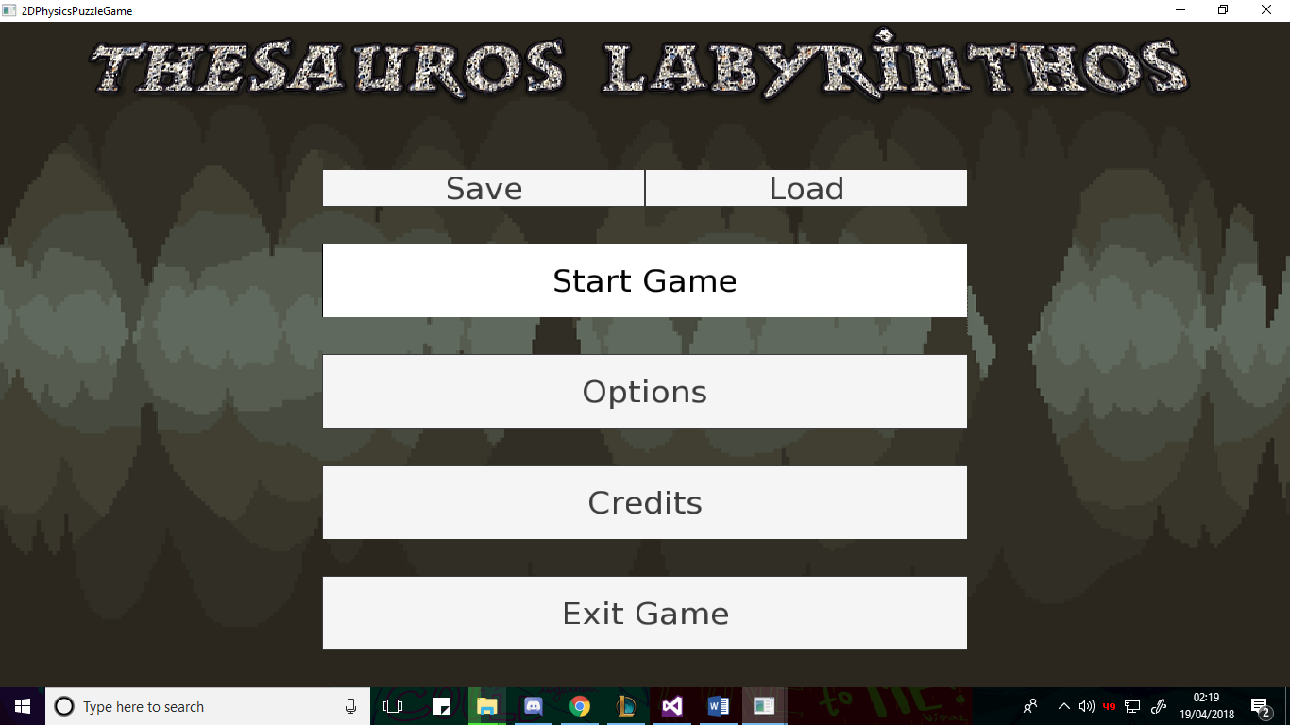

## Game Instructions

### Controls

* W – Climb rope
* A – Walk left
* D – Walk Right
* Space – Jump / Fly / Wall Edge Jump
* K – Shoot Arrow
* Q – Swap Current Item
* E – Use Current Item
* Shift – Shield if acquired.

For Debug Purposes:

* L – Next level
* V – Player Lose Life

### GamePlay

## Game / Project maintenance

Player must navigate the maze to find the exit leading to the next level. Player can collect treasure that they can use to upgrade themselves. Can also find Treasure Chests that will open upon collision and will give a random item. Useable items are added to player.

Useable items can be activated to change how the game plays or interact with surroundings. Activating them will put them on cooldown for a time.

Traps are scattered around the levels, both lethal and not, as well as different enemy types that will try to kill or hinder the player.

The player’s light will gradually dim as their fuel decreases, only being replenished from certain items from treasure chests and buying more from upgrades. Shielding will make the player invincible and will drain their energy. Fuel , Energy, current item, item cooldown, Health and treasure can be seen on the gui at the top.

Minimap at the top shows the area around the player.

Every third level will be an upgrade point where the player can spend their treasure on upgrades and more health and fuel. The player can either continue deeper into the maze or begin their retreat run. The retreat run will send the player back through all of the previous levels, rewarding the player if they manage to get all the way back by allowing them to keep any items for their next attempt and with a bit of treasure.

If the player dies, it is permadeath. Death will send the player back to the main menu, removing all non-default items from them and causing them to lose a portion of the treasure they had.

### Running Game

To run the game, sfml and tgui are needed, as such the .dlls for those are required to be kept in the folder with the exe. The Assets folder is also required alongside the exe otherwise the textures will not draw. Box2d is built into the exe. Run Exe to run the game

### Visual Studio Solution Maintenance

To edit, run or maintain the project solution, the external libraries folder needs to be kept alongside the project folder, one back from the solution direction, see below. The include needs to have the dll files for sfml and tgui for functionality. The external libraries folder must include the SFML, TGUI and Box2D library folders.

